

Resource Adequacy Modeling & Program Design
RAAIM and Outage Substitution (Track 2)
Second Revised Straw Proposal
October 2, 2026

Prepared by: [Author’s Name]
Version: [if applicable]

California Independent System Operator

Executive Summary
California’s resource adequacy (RA) framework relies on a clear division of responsibilities: local regulatory authorities (LRAs) establish planning requirements, counting rules, and procurement obligations, while the ISO is responsible for ensuring that capacity shown as RA is visible and operationally available in the ISO markets. This second revised proposal in Track 2 of the ISO’s Resource Adequacy Modeling & Program Design initiative maintains that structure while further developing operational tools intended to improve resource availability during stressed system conditions.
Stakeholders concluded in the working group effort that the current Resource Adequacy Availability Incentive Mechanism (RAAIM) requires reexamination. Static availability assessment hours, many exemptions, monthly averaging, the existing deadband, and relatively low non-availability charges can reduce accountability for unavailability during critical hours. At the same time, scheduling coordinators have provided limited substitute capacity for resources on forced outage, and the cost of obtaining substitute capacity may exceed current RAAIM penalties. These conditions support continued development of a more targeted availability incentive and improved outage-substitution processes.

Building on the July proposal, the ISO continues to advance an event-based RAAIM framework focused on resource availability during stressed system conditions. This iteration further develops the assessment methodology and pricing rationale, including supporting historical analysis. It also proposes a framework for limiting cumulative penalty exposure to provide greater financial predictability while maintaining meaningful availability incentives.
The proposal continues to recognize the distinct roles of forward accreditation and operational availability incentives. UCAP reflects historical availability in a resource’s forward RA counting value, while revised RAAIM addresses whether shown RA is available during identified reliability events. Development of these reforms will proceed in coordination with UCAP implementation and other LRA program requirements.
Related refinements to system RA bidding requirements (the must-offer obligation) would reflect the deliverable portion of resource capacity while retaining shown RA capacity as the basis for RAAIM and substitution exposure. The proposal also clarifies how availability assessments account for different resource operating characteristics and continues to develop refinements to the outage substitution processes and outage definitions. Together, these changes are intended to clarify resource obligations and support timely maintenance and access to substitute capacity.

1 Background
All Regional Transmission Organizations and Independent System Operators (RTOs/ISOs) across North America have resource adequacy functions within their balancing authority areas, but the entity responsible for these functions is different in each RTO/ISO footprint. Some RTOs/ISOs have a stronger role in forward planning and procurement including the direct procurement of resources multiple years forward. Others defer more to their constituent regulatory authorities (state public utility commissions, etc.) in conducting integrated resource planning and procurement.
In California today, LRAs, load serving entities (LSEs), scheduling coordinators (SCs) and the ISO all perform critical roles in ensuring a well-functioning RA program. This revised straw proposal builds on that framework by further developing operational rules for availability incentives, system RA bidding requirements, outage substitution, and outage coordination, while maintaining the existing division of responsibilities. In general, the LRAs have the primary roles in setting system requirements and counting rules, conducting integrated resource planning, and directing procurement of new and existing resources. The ISO, in turn, has the responsibilities in the shorter term to ensure resource adequacy capacity is available and performing reliably in ISO markets. Key responsibilities within the scope of the ISO’s operational role in resource adequacy include:
- Accounting for RA capacity via supply plans and RA plans
- Imposing must-offer obligations in the ISO market
- Assessing availability incentives
- Coordinating and approving outages
- Procuring backstop capacity to meet gaps or deficiencies in resource adequacy procurement
Given the ISO’s unique role in operating the grid, it is appropriate for the ISO to stay closely coordinated with LRA program designs and provide insight into the operational needs of the system.
Each design element included in the ISO’s scoped RA reform initiative is intended either to improve an existing ISO operational process or to provide LRAs with information relevant to reliable and efficient planning. Track 2 of RAMPD focuses on event-based RA availability incentives, system RA bidding requirements, outage substitution, and outage definitions. These reforms are intended to improve the availability and visibility of shown RA capacity during stressed system conditions while maintaining the respective planning and operational roles of LRAs and the ISO. Related issues that require additional development, including a potential future performance assessment and the longer-term treatment of Flexible RA, are identified separately in this proposal.

2 Availability Incentives

History of the Resource Adequacy Availability Incentive Mechanism (RAAIM)
RAAIM is the ISO’s primary mechanism to incent resources counted toward resource adequacy obligations to be actually available when system reliability depends on them. Resources compensated for providing RA capacity should be operationally available in all hours, but particularly during the hours when the system is most at risk. RAAIM provides that link by creating a measurable availability metric and associated financial consequences for underperforming.
RAAIM was created and enhanced as a part of a multi-phase reform process and was designed to replace the Standard Capacity Product (SCP) framework. The SCP attempted to standardize RA capacity by attaching defined availability requirements and performance incentives to capacity counted toward RA. The SCP framework had both operational and policy challenges and was largely viewed as ineffective in targeting critical periods and created administrative complexity. RAAIM’s key design was meant to simplify the process and make the design more effective in targeting availability incentives
Under the current RAAIM design, each year, the ISO designates a set of Availability Assessment Hours (AAH) intended to represent periods of elevated reliability risk for both system (also known as generic) and flexible resource adequacy. The hours are typically concentrated on peak demand hours on non-holiday weekdays and periods of high ramping need morning/evening ramp for meeting the flexibility needs. The ISO evaluates whether RA resources subject to RAAIM satisfied their must-offer obligations based on submitted bids. In order to avoid RAAIM penalties during outages, RA resources must provide substitute capacity during an outage period. The current evaluation focuses on availability (self-scheduled or economic bids) rather than dispatch or performance.
Each month, the ISO calculates an availability performance metric for each resource based on its availability across applicable availability assessment hours. This produces a monthly availability percentage compared against a defined performance standard, including applicable deadband provisions to allow minimal periods of unavailability without consequences. Resources performing below this standard incur non-availability charges tied to 60% of the CPM soft offer cap which, when collected, are used to fund payments to resources that are available more than the performance standard requires.
RAAIM serves several policy purposes to ensure the ISO’s operational abilities and to align incentives with LSE contracts.
RAAIM is designed:
- To encourage resource owners to plan and conduct maintenance to ensure resources are available
- To incent timely return to service following unplanned outages, or procurement of replacement capacity, reducing the duration of RA deficiencies, and
- To provide assurance to LSEs that RA capacity will be reliable
So, by giving RAAIM “teeth,” the design was intended to support LRA’s RA programs by providing a consistent method of penalizing non-availability. This allows for consistent incentives, which leads to more fungible capacity by reducing the complications that would come with each LSE and LRA needing their own availability incentives for capacity contracted to their respective programs.
Despite improvements, stakeholders have identified limitations in RAAIM as it exists today, partly by the design but also by limitations in the objectives:
From a design perspective, averaging availability across all AAH in a given month is seen to dilute accountability signals, as a resource could be unavailable during the most critical hours but still achieve an acceptable monthly average by performing well across lower-risk hours. This is further exacerbated by the deadband around the performance standard which can weaken incentives and a RAAIM incentive level that is tied neither to system conditions or the implicit reliability consequence costs of grid emergency conditions. Resources that are unavailable during grid emergencies or high stressed intervals face the same RAAIM settlement as those unavailable during lower risk hours.
The CAISO Department of Market Monitoring along with other stakeholders also highlighted a potential challenge with the RAAIM construct in examining only day ahead availability. DMM’s and the ISO’s analyses have shown a potential gap between resource availability day-ahead and actual real time performance. DMM recommended pairing a day ahead availability incentive with a complementary real time and performance incentive mechanism, with similar functions where the real time performance incentive should be assessed specifically during tight grid conditions.

Problem Statements and Objectives
As a part of the 2023-2024 RAMPD working groups, the following sub-issues related to RAAIM were identified as a part of the larger RA problem statement:
- In light of a tight RA market, high RA prices, and market incentives, RAAIM may be an ineffective incentive mechanism to ensure capacity is bid into the market. For example, RAAIM is applied only to a fraction of the RA fleet, the current deadband provides insufficient incentive to be available and both the monthly netting process and carry-forward provisions mute incentives. In some cases, this can result in incentivizing less reliable generation to be contracted and discouraging scheduling coordinators from showing all of their RA resources to the ISO. Additionally, when RAAIM does not incent capacity to be available, it creates operational backstop challenges for the ISO, as substitute capacity has not been shown, resulting in potential reliability risks.
- RAAIM should be assessed to see if it is meeting its intended objectives, what new objectives should be established, and if a new mechanism is needed to incent availability and/or performance. The need for either RAAIM reform or RAAIM elimination as well as any exploration of a new availability and performance mechanism should be done in concert/consideration of any counting rule changes to encourage all RA-eligible resources to be shown.
To address these and other concerns, the ISO has embarked on this multi-part effort to evaluate reforms to its resource adequacy processes and tools. As part of Track 2 of this effort, the ISO seeks to address widespread stakeholder and ISO concerns about the current availability incentive mechanism, the resource adequacy availability incentive mechanism (RAAIM). Based on stakeholder feedback, the ISO seeks to design mechanisms that ensure resource availability and performance while aligning with California’s hybrid regulatory structure. Maintaining this structure means that LRAs continue to play the primary role in setting resource accreditation and planning reserve margins, and the ISO, in turn, has the primary role in “operationalizing” RA capacity to ensure it is available in the energy markets when needed.
In the November 2024 RAMPD issue paper, the ISO discussed how to effectively balance LRA UCAP designs and other accreditation methods that can provide availability incentives with reforms to the ISO’s availability and performance incentives. As the CPUC moves forward with its UCAP accreditation methodology, the ISO and stakeholders have discussed if, or the extent to which, an additional availability and performance incentive is still needed to provide even a stronger incentive during critical periods or to align cost allocation with cost causation. Stakeholders recognized that there might be differences across the CAISO BAA with UCAP implementation, since it is likely that not all LRAs will adopt UCAP, and LRAs likely would not apply this QC methodology to all resources. While the newly proposed default methodology generally allows for a resource-specific adjustment to a class-based QC value based on individual resource performance, it is unclear which LRAs will adopt these default rules. In any case, FERC has recognized that having both a capacity performance/availability derate via accreditation and an availability incentive mechanism (like RAAIM) does not necessarily constitute a double penalty for capacity resources. The ISO’s current RAAIM design provides an incentive to offer capacity that has been sold into the energy markets, whereas the capacity derate from methods such as UCAP reflects the quantity of dependable capacity going forward.
The RAMPD Track 2 initiative also has the objective of aligning availability mechanism design with outage and substitution rules. In the recent past, the ISO’s RAAIM penalty price has been far below the cost of finding substitute capacity. This means there has been little incentive to replace capacity that is subject to a forced outage. This initiative seeks to align incentives for availability so that there is sufficient capacity to operate a reliable grid.
Considering the various RA functions described above, the ISO believes a good design, between accreditation process and availability incentives, should incent RA resources to:
- Reduce forced outage rates from all resource types particularly during stressed grid conditions
  - Perform planned maintenance and, as needed, invest in larger capital upgrades
  - Return quickly from forced and planned outages in advance of forecasted extreme conditions
- Align shown RA shown values with the expected ability of those shown resources to bid and perform
- Offer into the energy market day in, day out in accordance with their must-offer obligations; particularly during critical hours
These three behaviors could be encouraged by a combination of energy market price signals, a RAAIM-like operational tool, and QC methodologies.

Data Analysis
In the 2024 RAMPD Issue Paper, ISO staff analyzed recent historic RA capacity resource availability and performance data. At a high level, the takeaways from this analysis are:
- The current RAAIM penalty ($4.40/kW-month) is far below bilateral trading prices
- Forced outage rates for RA resources have increased
This section serves as a summary of that data analysis which provides useful context for evaluating the existing RAAIM framework. This includes the relationship between penalty levels and substitute capacity costs, the effect of monthly averaging, and the extent to which forced-outage substitution occurred during the periods reviewed.
Regarding the increase in forced outage rates for RA resources, this trend may be consistent with several contributing factors, including limited opportunities and incentives to schedule planned maintenance, difficulty obtaining substitute capacity, other limitations to dispatch that show up as outages in the ISO system or a decision to accept the RAAIM penalty where the cost of replacement capacity exceeds the expected penalty price.

Figure 1: Summer 2021-2023 Planned and Forced Outage Rates
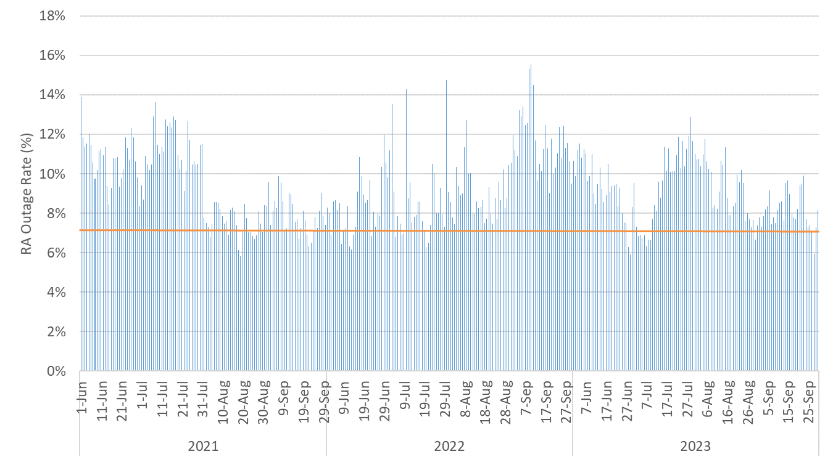
In Figure 1, showing combined outage rates for planned and forced outages, forced outages account for 97-98% of all outages in summer months. The orange line indicates the 7.5% forced outage rate assumption made in the 2024 Summer Assessment. In light of higher outage rates, this number has since been updated in both the 2025 and 2026 Summer Assessments and is now assumed to be higher than 7.5%. Figure 2 shows the assumptions used in the most recent ISO Summer Assessment.
Figure 2: Capacity-weighted average forced outage rate assumptions in 2026 Summer Loads & Resources Assessment by resource type (based on 2022-2025 data)
Capacity-weighted average forced outage rate (%) | Battery storage | Thermal combined cycle | Thermal  gas turbine | Hybrid
Capacity-weighted average forced outage rate (%) | 10.7% | 5.3% | 7.7% | 11.4%

Figure 3 shows an even higher outage rate for RA resources during the first half of September 2022, a time when the ISO grid experienced extreme conditions from a late-summer heat wave.
Figure 3: September 1-15, 2022 Daily RA Resource Outage Rates (both planned and forced)
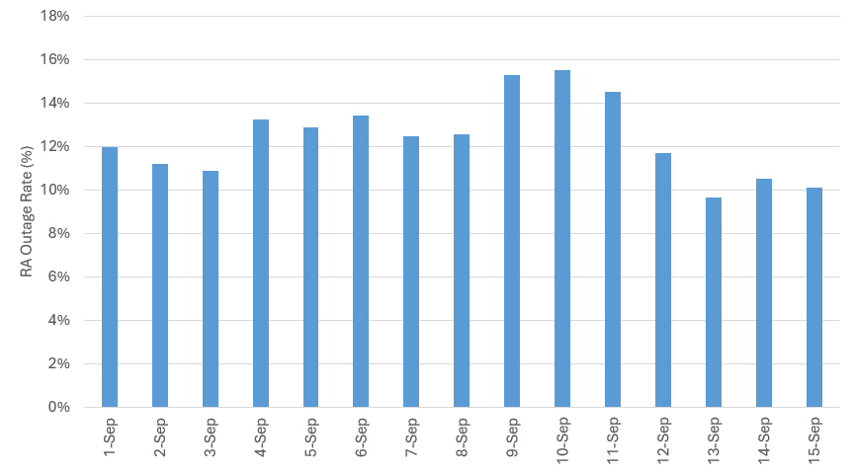
In the November 2024 RAMPD issue paper, ISO staff reviewed performance (metered output relative to market award) and availability (forced outages and bids) of RA resources during September 2022. Note that there was only about 2,500 MW of energy storage capacity on the ISO grid during this period, but it represents the most recent period of significant capacity constraints during a CAISO EEA.
Below are two key data visualizations from this time period, including the September 2022 heat wave.

Figure 4: September 2022 Daily RA Availability and Performance
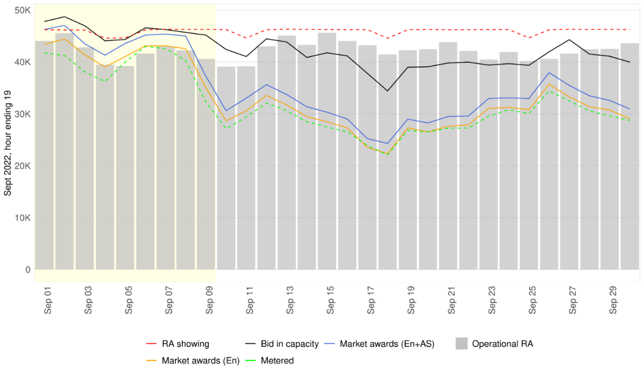
Figure 5: September 2022 RA Availability and Performance for Gas, LESR, Import, and Water Resources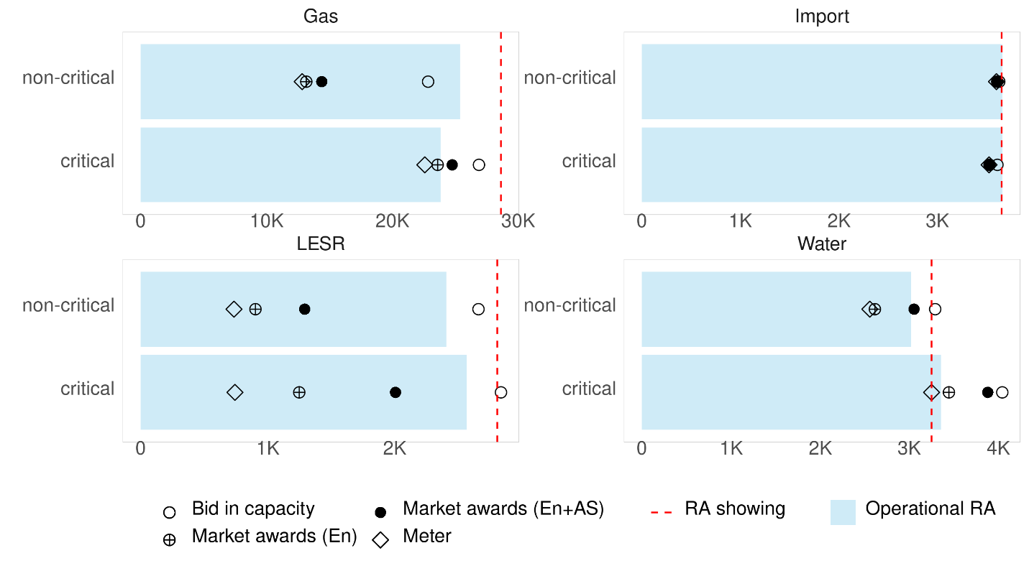
The ISO summer market performance report for September 2022 indicated that “on average, resource adequacy resources performed to their expected output, including new resources on the grid such as battery storage.” In figures 4 and 5, bid-in capacity generally matched RA showings at the system level on critical days (early in the month of September 2022), though for gas resources, there was a gap between bid-in capacity and shown RA for critical periods. However, operational RA was below shown RA for thermal and storage resources during both critical and non-critical periods, which was likely caused by forced outages. Additionally, actual metered performance fell below energy awards, with thermal and storage showing weaker performance than hydro and imports on a relative basis.
This data also shows that a meaningful share of system RA resources did in fact operate inside the current RAAIM deadband (94.5 – 98.5% availability during AAH) across the entire month of September 2022. In this case, RAAIM’s incentive signal is diluted during extreme conditions, which generally last days, not the whole month. If a resource were available for 95% of the month’s availability assessment hours, it would not be subject to RAAIM charges. However, it may have been on a forced outage during the five hours of the month that were the most critical for the grid.
Beyond September 2022, RAAIM non-availability charges have been rising on a monthly basis over time, especially for thermal resources. This may reflect broader trends of difficulties in taking maintenance outages or a preference to suffer the RAAIM penalty rather than find higher-priced substitute capacity in the bilateral market.
Regarding replacement of RA capacity on outage, forced outages were not replaced with substitute RA capacity in the summer months of 2022 and 2023. For June to October 2022 the average substitution for forced outages ranged between zero to one percent. For June to October 2023 the average substitution ranged from one to 11 percent. However, when only looking at the summer months of June, July, and August in 2023 the substitution rate averaged one to three percent. It appears that RAAIM is either not providing enough of an incentive for resources to provide substitute capacity during forced outages, or there was simply not enough excess capacity to provide replacement for forced outages during these periods.

Figure 6: Average June - October 2022 Forced Outage RA Substitutions

Figure 7: Average June – October 2023 Forced Outage RA Substitutions

Taken together, this evidence indicates potential concerns where the price and timing of incentives might not align well with reliability needs during the hours and days that matter most for the grid. While it appears that those resources that were not experiencing a forced outage generally had bidding behavior and performance that met planning assumptions, forced outage rates for thermal and storage RA resources in September 2022 were higher than shown RA values. To some extent, this is to be expected due to current LRA QC methodology, which currently does not account for forced outages or performance for these resource types at all, but it also reveals potential questions about market tools to incentivize performance at the resource-specific level.
Accordingly, the ISO views this historical analysis as relevant context for evaluating the availability incentive framework, rather than as the sole basis for any final trigger, penalty, or settlement design. The analysis helps identify the types of design questions addressed later in this paper, including how incentives should account for the timing of non-availability, the cost of substitute capacity, and periods of elevated reliability risk.

Stakeholder Feedback

The ISO appreciates the detailed feedback on the July 17 revised straw proposal and July 22 stakeholder meeting. This second revised straw proposal provides further detail when Tier 1 assessments would apply, presents supporting pricing analysis, and proposes limits on monthly penalty exposure. It also refines bidding requirements to reflect capacity delivered for RA purposes, while retaining shown RA as the basis for RAAIM and substitution obligations. Additional clarifications address resource-type treatment, the substitution shopping cart, and outage classifications. The ISO seeks further feedback on these refinements and their implementation with UCAP.
Coordination with UCAP accreditation, which adjusts RA counting values for expected availability, remained a priority for AES, WPTF, PG&E, and Calpine. They sought a clearer explanation of how those values would work with RA showings, bidding obligations, penalties, and outage requirements before broader reform. CESA, NextEra, Terra-Gen, and Vistra similarly favored prioritizing UCAP implementation and related clarifications. CalCCA, SDG&E, and SCE supported further development of targeted availability incentives with refinements, with SDG&E favoring coordination without delaying event-based reform. MRP preferred targeted improvements to the existing mechanism, while AReM encouraged timely initiation of RAMPD Track 3B to coordinate related changes.
Questions about Tier 1 centered on how much more advance notice resources need and whether assessments should remain in effect when forecasts improve. SDG&E supported confirming assessment hours three days before the trade date, while ACP-CA, AES, Six Cities, and WPTF favored cancellation if forecasted stress subsided. The CPUC Energy Division preferred confirmation one day ahead, and CalAdvocates favored retaining the existing Availability Assessment Hours with a relatively low Tier 1 penalty price. CalCCA, CDWR, NCPA, and SDG&E requested clearer explanations of the uncertainty adjustment and historical analysis of when assessments would apply. The Energy Division also recommended using installed capacity (ICAP) less outages to determine available RA. CalCCA, SDG&E, and ACP-CA opposed establishing a minimum number of assessment hours, arguing that RAAIM reform should remain focused on identified system stress rather than meeting a predetermined number of hours.
The proposed Resource Sufficiency Evaluation (RSE) trigger for Tier 2 received support from the Energy Division, with SCE emphasizing that resource availability remains important during scarcity regardless of its cause. However, the possibility that procurement deficiencies, forecast changes, or import availability could drive an RSE failure led AES, WPTF, MRP, and Six Cities to seek a clearer connection to unavailable RA. Emergency-based alternatives proposed by AES, CESA, and Vistra would instead tie assessments to declared emergency conditions.
The proposed penalty prices drew both calls for stronger incentives and concerns about excessive financial risk. The DMM recommended setting RAAIM prices to discourage resources from selling more RA capacity than they can reasonably expect to make available. Expected penalties for non-availability should meet or exceed the financial benefit from those additional sales. SDG&E generally supported the proposed day-ahead energy price for Tier 1, while AES, NCPA, Calpine, Vistra, and WPTF preferred capacity-price references, including the use of Reliability Capacity Up. To limit overall exposure, ACP-CA, Calpine, and NextEra identified the Capacity Procurement Mechanism (CPM) soft offer cap – the ISO’s backstop procurement price reference – as a possible basis for penalty limits. Furthermore, SCE favored continuing reduced charges after an initial threshold so resources would retain an incentive return to service.
Similar to the previous round of comments, penalty revenue allocation reflected differing priorities. The Energy Division and Six Cities favored allocating all penalties to load, including offsetting relevant RSE costs. Many supply-side stakeholders including NextEra and Vistra favored rewarding resources exceeding their assessment benchmarks, while CESA supported payments to resources meeting or exceeding obligations. Separately, DMM cautioned against allocations that weaken LSE incentives to procure sufficient RA.
The July proposal’s limit on assessments to capacity actually shown as RA received support from AES, CDWR, NextEra, SDG&E, and Six Cities. However, stakeholders differed on whether the must-offer obligation (MOO) – the quantity required to be offered into the market – should also be limited to shown RA. CDWR, NCPA, and Six Cities favored that limit, while AES, WPTF, MRP, and Vistra recommended using deliverable capacity rather than a resource’s unrestricted physical maximum, or Pmax, in the proposed calculation. AReM and the Energy Division sought clarity on how a higher bidding obligation would be enforced. CalCCA favored assessing RAAIM against the full MOO, while the Energy Division recommended that approach where other measures did not provide the necessary incentive. Furthermore, Cal Advocates and the Energy Division also favored having LRAs provide MOO values, with CalAdvocates highlighting resources shown across different LRA programs. Vistra recommended adjusting the capacity assessed under RAAIM to reflect system needs and converting RA showing under different LRA rules into comparable amounts of deliverable capacity, so combined commitments do not exceed what a resource can provide.
The Energy Division and SDG&E welcomed the distinction between VER equipment outages and weather-driven variability. On the other hand, ACP-CA and AES continued to recommend retaining the VER exemption pending further evidence of reliability benefits, citing existing production incentives and contractual impacts. For storage, AES, CalCCA, CESA, and SDG&E requested protection from nonlinearity-related RAAIM exposure before the modeled solution is implemented. AES also sought examples addressing state-of-charge, duration, charging requirements, and shared interconnections limits. Terra-Gen recommended retaining the hybrid exemption until the applicable UCAP methodology and assessment rules are more fully defined.
CDWR and State Water Contractors supported retaining the Participating Load exemption. NCPA similarly welcomed continued exemption for load-following MSS resources. For hydro and other use-limited resources, SCE sought bidding obligations that respect water and fuel constraints. WAPA supported the shown-RA assessment basis for hydro and requested clarification of use-limited bidding requirements. The proposed suspension of Flexible RA-specific penalties also received support from ACP-CA, CalCCA, CDWR, CESA, and Terra-Gen.
The proposed substitution shopping cart, which would help participants identify replacement capacity while retaining bilateral transactions, received support from CalCCA, the Energy Division, SCE, and Six Cities. DMM and Cal Advocates sought a clearer explanation of how it would improve existing tools, while AES, MRP, and WPTF highlighted the credit reviews, contracting requirements, eligibility checks, and short transaction timelines that could still limit its use. SDG&E supported further exploration but requested protection for commercially sensitive capacity positions and procurement strategies, opposed any future requirement to post all excess capacity, and questioned whether the tool would increase substitute capacity availability during tight supply conditions. CESA called for a more effective substitution market to planned maintenance, while Vistra recommended easing substitution requirements when an outage would not create a reliability concern.
Regarding outage definitions, SCE and Six Cities emphasized the importance of short-notice opportunity outages for timely maintenance. Calpine, AES, Terra-Gen, Vistra, and WPTF likewise favored retaining or refining the category so resources can address equipment conditions before they develop into forced outages. Also, PG&E, AES, MRP, and WPTF sought clearer distinctions among planned, urgent, and forced outages, including their implications for UCAP, RAAIM, and substitution.

Proposal
There are a variety of methods to reflect the availability of plants in modeling, accreditation and incentives. Until UCAP is implemented at the CPUC and/or adopted by other LRAs potentially via the ISO’s default rules, the CPUC or other LRAs account for the impact that forced outages and unit derates have on system reliability at a resource-specific QC level for a majority of the units in the CAISO footprint. Instead, the ISO relies on LRA PRMs to account for forced outages at a portfolio-wide level. The ISO also relies on operational tools such as planned outage substitution rules and RAAIM to discipline capacity in the operational timeframe. However, the introduction of a UCAP QC methodology at the CPUC will eventually capture some of the variability in availability in the forward planning period for the applicable set of resources.
However, even a resource-specific UCAP accreditation methodology is not a silver bullet to quantify all facets of RA resource availability. By itself, resource-specific UCAP will not recreate the benefits of a layered approach that combines QC methodology with availability and performance incentives. Other ISOs/RTOs also combine up-front availability in resource accreditation with penalties assessed in the operational timeframe if resources do not bid or perform. Any RAAIM reform option will have to consider how UCAP is adopted by each LRA, which resources it applies to, and if there is still a need to incentivize capacity though an availability or performance mechanism.
Reforms to RAAIM could take a multitude of approaches. If the ISO were to remove the current RAAIM tool, it could be replaced with, on one end of the spectrum, a reliance on market prices or, on the other end, with strict non-performance penalties. A middle ground could look like a more focused availability incentive, which the ISO proposes here. Consistent with that approach, the ISO proposes that revised RAAIM remain focused on operational availability for shown RA capacity. The proposal does not alter LRA authority to establish RA counting methodologies or LSE procurement requirements, and is intended to complement, rather than replace, LRA accreditation frameworks such as UCAP.

Figure 8: Overview of proposed RAAIM reforms

Design Element | Today’s RAAIM | Proposed RAAIM Reform
Criterion | Status quo: assess availability by comparing a resource’s shown RA to its day-ahead (and in some cases, real-time) energy offers and outage status
Assessment period | AAH (5 consecutive clock hours on each weekday – hours determined for each season based on CAISO annual study) | Two assessment triggers:  Tier 1 – an energy reliability assessment  Tier 2 – capacity scarcity conditions (CAISO BAA day-ahead RSE upward sufficiency failure)
Price | $4.40/kW-month (set to 60% of CAISO’s CPM soft offer cap) | Tiered pricing:  Tier 1 – day ahead LMP  Tier 2 – $2,000/MWh
Assessment frequency | Netted across each calendar month – resources that are bidding between 94.5% and 98.5% of intervals are not paid or penalized | “Per event” – assess energy offers in each day-ahead hour individually
Bounded penalty exposure | N/A | The ISO would assess each resource’s monthly Tier 1 and Tier 2 charges at full rates up to 100% the CPM soft offer cap, then at 20% of the applicable rate until total charges reach a hard cap of 200% CPM. Exposure resets monthly with no carry over
Exemptions | Numerous (resource type-specific; contract-based; outage-based; MOO-based; and Flex RA-only capacity) | See Figure 9 and resource type-specific discussion below; Section 3 addresses related MOO and bidding rules. Refine categorical exemptions through resource type-specific treatment, with revised RAAIM exposure based on shown RA. Eliminate <1MW exemption
Allocation of non-availability charge funds | Charges collected from unavailable resources is allocated back to resources that demonstrate a reasonable level of availability and to load

The ISO proposes key reforms to RAAIM based on stakeholder feedback and the challenges with RAAIM’s current design as described above. RAAIM should remain an availability assessment tool that compares offers, schedules, and outage status to a resource’s shown RA capacity during reliability-critical event intervals. Separately, the ISO is proposing must-offer obligation rules to preserve requirements and market visibility into operational capability, including circumstances where a resource’s MOO may exceed shown RA because its accredited RA value is below its physical operating capability. A MOO above shown RA would support reliability, operational visibility and dispatchability but would not by itself increase the MW quantity subject to revised RAAIM charges.
With that distinction, the ISO proposes to refine categorical RAAIM exemptions by moving, where appropriate, toward availability assessments that vary based on the resource type. Under this approach, each resource generally would be assessed against the shown RA capacity it was obligated and physically capable of making available during the relevant Tier event. Applicable offers, schedules, outage status, physical limitation, program and dispatch limitations, water or fuel availability limitations, and other operational constraints will be used in determining whether non-availability should create RAAIM exposure.
The ISO does not intend this approach to impose a uniform dispatchable-resource availability test on all resource types. Rather, the ISO intends the approach to reduce broad exemptions where shown RA capacity is unavailable due to controllable plant trouble or failure to meet applicable bidding or scheduling obligations, while retaining or developing tailored treatment in cases when a resource type has a valid basis for different treatment.
The ISO recognizes that additional implementation details will need to be developed as the proposal is further refined. Those details will address how the ISO identifies applicable availability obligations, the role of the must-offer obligation, and the resource type limitations recognized in the availability assessment. This further development will be guided by the principles that revised RAAIM charge exposure remains capped at shown RA and that the assessment reflects the applicable obligations and operating characteristics of each resource type.
Figure 9 summarizes the proposed basis for assessing availability by resource type. Revised RAAIM charge exposure would remain capped at shown RA, while the information used to determine whether that shown RA was available would vary by resource type. The subsections below provide additional detail.

Figure 9: Alignment Between Resource Types and RAAIM Exposure

Resource Type | Current RAAIM Assessment or Exemption | Enhanced RAAIM Assessment
Thermal Resources | Assessment based on shown RA | Assess shown RA using applicable bids, schedules, and outage or derate status.
Storage Resources | Assessment based on shown RA | Assess shown RA using applicable bids and outage status. Specific treatment for resource type limitations
VERs | Fully exempt based on variability | Assess reported applicable outages against shown RA. Expected wind and solar forecast variability would not create revised RAAIM exposure.
Run-of River Hydro | Exemption if applicable accreditation methodology is used | Assess variability based on shown RA, expected water availability or expected energy, and outage status. Legitimate hydrology limitation would not create exposure.
Dispatchable Hydro | Exemption for certain outage natures of work relative to QC | Assess shown RA using applicable bids and outage status.
Participating Load/  Pumping Load | Currently exempt | Retain current exemption status
Demand Response | Exemptions based on program and dispatch limitations | Retain existing program and dispatch-limitation framework. Revised RAAIM would assess only the existing tariff or program obligation for each DR resource type.
Load-Following MSS | Exempt due to portfolio scheduling constraints | Retain current exemption status
<1 MW Resources | Exempted for administrative simplification | Eliminate the blanket size-based exemption and assess shown RA under the otherwise applicable resource type rules

Resource Type Application of Revised RAAIM
The ISO tariff applies different bidding, scheduling, and availability requirements across RA resource types, reflecting differences in dispatchability, physical and energy limitations, program rules, and LRA counting methodologies. Resources may also be subject to bid insertion, outage reporting, and RAAIM, but those requirements do not operate identically across the RA fleet. A revised RAAIM framework therefore cannot rely on a single availability assessment for all resource types.

Current RAAIM relies on categorical exemptions for certain resource types for a variety of reasons. The current rules recognized that availability in the AAH hours may be affected by weather, hydrology, SOC, or other operational limitations. The ISO proposes to refine those exemptions where available information can distinguish controllable non-availability from legitimate operating limitations, while retaining current treatment where a standard resource-level assessment would not accurately reflect the resource’s obligation. The following discussion describes the current obligations and RAAIM treatment for resource types, the proposed assessment, and any remaining implementation concerns.
- Thermal / Dispatchable Gas
Thermal resources with RA capacity committed to the CAISO are subject to applicable must-offer obligations in the day-ahead and real-time markets. In the day-ahead market, these resources generally must submit economic energy bids or self-schedule for the RA capacity in applicable Integrated Forward Market intervals, and the ISO applies applicable bid-insertion or reliability capacity rules where bids are not submitted. In the real-time market, thermal resources must submit bids consistent with their applicable real-time must-offer obligations and outage status.
Thermal dispatchable resources are fully subject to RAAIM today. The current RAAIM framework measures availability against the applicable availability standard during Availability Assessment Hours (AAHs) and applies non availability charges where a resource falls below the performance standard, subject to applicable deadband and substitution rules.

Under the revised RAAIM framework, the ISO proposes to assess thermal resources during Tier events based on shown RA MW. A thermal resource would be required to bid the full amount of its shown RA to avoid RAAIM exposure and accurately report any outage through the applicable outage process. Revised RAAIM exposure would apply to any portion of shown RA that is unavailable during a Tier event and is not covered by substitute capacity or applicable outage or derate treatment.
Assume a fully deliverable thermal resource with 100 MW Pmax, 80 MW NQC, and 80 MW Shown RA. For this example, NQC incorporates an accreditation derate, and the normal-condition MOO is 100 MW under the calculation described in Section 3.
Figure 10: Thermal resource example
Assessment step | Case A: Smaller equipment derate | Case B: Larger equipment derate
Documented equipment derate | 10 MW | 30 MW
Remaining capability offered | 100-10 = 90 MW | 100-30 = 70 MW
Shown RA | 80 MW | 80 MW
Unavailable RA | max(0, 80-90) = 0 MW | 80-70 = 10 MW
In Case A, remaining capability offered exceeds shown RA, so no shortfall would be assessed. In Case B, the assessment would reflect the 10 MW shortfall below shown RA, rather than the full 30 MW equipment derate or the difference from the normal-condition MOO.
- Non-Generator Resources

Standalone battery storage resources participate through the Non-Generator Resource (NGR) model, using economic bids to indicate their willingness to charge or discharge. Under existing requirements, storage providing System RA must submit applicable energy bids covering its RA capacity in the discharging range. Storage is currently subject to RAAIM based on submitted bids and outages under the monthly availability framework.
The ISO proposes to retain shown RA availability assessment for storage during applicable Tier-event hours. Availability would be determined using required bids and reported outages, with charges applying to unavailable shown RA not covered by substitution or applicable outage treatment. At this time, CAISO is not proposing adding a separate state-of-charge, charging-sufficiency, duration, or energy performance assessment. Evaluating those factors would require additional design beyond the proposed assessment of availability through bids and reported outages. Any additional energy-sufficiency or performance checks would be considered through future policy development addressing real-time energy availability and performance.
The ISO is implementing a modeled solution in the market. The modeled solution would allow resources to submit full bid curves while accounting for physical operating limits, without deviating from schedules or reporting an outage solely for modeled nonlinearity. The ISO is not proposing an interim exemption while the modeled solution is pending. Existing rules would remain in effect until the relevant changes are approved and implemented.
Assume a standalone battery has 100 MW of maximum discharge capability. For this example, a 20% UCAP derate is reflected in an NQC of 80 MW, and the resource shown 80 MW as RA. During an applicable Tier-event assessment hour, a non-exempt equipment outage reduces discharge capability by 25 MW with no substitute capacity assumed.
Figure 11: Standalone battery example
Assessment step | Calculation
Max discharge capability | 100 MW
NQC after UCAP derate | 80 MW
Shown RA | 80 MW
Documented equipment derate | 25 MW
Remaining discharge capability | 100-25 = 75 MW
Unavailable RA | 80-75 = 5 MW
The UCAP derate reduces the battery’s RA counting value in this example, not its physical discharge capability. The equipment outage leaves 75 MW available, resulting in a 5 MW shortfall below shown RA, rather than an assessment of the full 25 MW equipment derate.
- Co-located & Hybrid Resources
Co-located resources retain separate resource ID, bids, and outage information, even when they share a point of interconnection (POI). Revised RAAIM would assess each underlying resource against its own shown RA under the rules applicable to that resource type. Sharing a POI would not combine these resources in a single availability assessment. Such a mechanism is not necessary because existing market mechanisms, such as the aggregate capability constraint, help manage the bids submitted by co-located resources to ensure their optimal dispatch subject to POI limits.
Hybrid resources, by contrast, are represented by one resource ID and a combined RA showing. The ISO proposes to assess hybrids as dispatchable resources, consistent with thermal generation and dispatchable hydro, using applicable bids and outages during Tier-event hours. The assessment would compare the combined resource’s assessed availability with its shown RA, rather than apply the standalone VER and storage methods separately to its components. Non-availability charges would apply to any shortfall below combined shown RA, subject to applicable substitution and outage treatment. Because the assessment would use day-ahead bids and applicable outage information, hybrid dynamic limits submitted in the real-time market would not affect the quantity assessed under revised RAAIM.
Solar-plus-storage is the predominant configuration in the hybrid fleet reviewed by the ISO and therefore provides the basis for the example below. Although hybrid configurations may differ in their operating characteristics, the ISO does not believe that differences in technology mix alone warrant separate revised RAAIM treatment. Each hybrid resource would remain responsible for managing the interaction among its components to support its RA commitment. For solar-plus-storage resources, this includes coordinating solar availability, stored energy, and charging arrangements.
Assume a solar-plus-storage hybrid represented by one resource ID has 100 MW of aggregate maximum capability and 80 MW combined shown RA. During an applicable Tier-event assessment hour, a non-exempt equipment outage reduces the hybrid’s aggregate capability by 35 MW. For this example, the bids and outage information establish the remaining capability as available for assessment, and no substitute capacity is assumed.
Figure 12: Hybrid example
Assessment step | Calculation
Aggregate resource Pmax | 100 MW
POI limit | 100 MW
Combined shown RA | 80 MW
Documented equipment derate | 35 MW
Aggregate availability | 100-35 = 65 MW
Unavailable RA | 80-65 = 15 MW
The 35 MW equipment derate reduces the hybrid’s aggregate available capability from 100 MW to 65 MW. Compared with its 80 MW combined shown RA, this results in 15 MW of unavailable RA. The ISO would assess this shortfall at the combined resource level, rather than calculate separate shortfalls for the solar and storage components.
- Variable Energy Resources (VERs)

VERs providing RA are subject to requirements reflecting their dependence on wind and solar conditions. They do not have a day-ahead MOO in the same manner as dispatchable RA resources; their market participation and real-time obligations are tied to available capability and forecasted generation. VERs are currently categorically exempt from generic RAAIM, recognizing their limited ability to change output when wind or solar conditions constrain output.
Under revised RAAIM, the ISO proposes to replace the categorical exemption with an assessment of documented, qualifying forced or urgent equipment outages during applicable Tier-event hours. Weather-driven variability, ambient conditions, and forecast error would not independently create RAAIM exposure, and output below shown RA or forecast would not, independently, establish equipment unavailability. Similar to today, outage cards would not be required solely for lack of wind, low irradiance, nighttime solar, or other ambient conditions reflected in the forecast.
The proposed assessment would express documented equipment outage MW as a percentage of resource Pmax and apply that percentage to shown RA. This proportional approach would measure the share of shown RA associated with unavailable equipment, with assessed MW capped at shown RA.
VERs generally have a much larger difference between installed and accredited RA capacity than thermal resources. Even when remaining installed capacity exceeds shown RA, the amount the resource can generate still depends on wind or solar conditions. Applying the thermal shortfall approach directly to VER installed capacity could therefore leave substantial equipment outages unassessed that significantly impact expectations around that resource’s unavailability.
Assume a VER has 500 MW Pmax, 100 MW NQC, and 80 MW shown RA. During an applicable Tier-event assessment hour, a non-exempt equipment outage affects 150 MW of its physical capability.
Figure 13: VER example
Assessment Step | Calculation
Resource Pmax | 500 MW
NQC | 100 MW
Shown RA | 80 MW
Equipment outage | 150 MW
Equipment outage as a percentage of Pmax | 150/500 = 30%
Unavailable RA | $$30\%*80 MW=24 MW$$
The 150 MW equipment derate affects 30 percent of the resource’s Pmax. The ISO would apply that percentage to the 80 MW shown as RA, not the 100 MW NQC, resulting in 24 MW of unavailable RA.
Based on stakeholder suggestions the ISO also considered a “but-for” approach that would estimate the output a VER would have produced without an equipment outage, using either an outage-free forecast or output from comparable resources as a proxy. The ISO’s current forecasting system does not provide the separate estimate needed for a forecast based assessment. Developing that capability or establishing a consistent method for using proxy resource would introduce additional implementation complexity which is currently not feasible. Alternatively, the CAISO could implement using a proxy approach, but such alternative would likely not fully reflect the lost energy of the specific resource on outage and could create additional implementation complexities.
The ISO therefore proposes the proportional derate approach, which applies the equipment outage percentage to shown RA without requiring a separate estimate of outage-free production. This method links assessed unavailability to the extent of the equipment outage and the resource’s RA commitment, rather than measuring the precise hourly loss of generation. The ISO could revisit a forecast-based assessment if necessary and welcomes stakeholder feedback on these or other approaches to assessing equipment unavailability for VERs.
- Hydro resources – Run-of-River and Dispatchable Hydro
Hydro resources require treatment that reflects both the source of the resource’s capability and the source of any limitation. Run-of-river hydro resources generally depend on expected water availability and expected energy. These resources must reflect current water conditions in their schedules or bids and update their market submissions when expected energy deliveries change. Dispatchable hydro resources with reservoir storage capability may have greater operational control, but their availability can still be limited by water budgets, release requirements, environmental restrictions, licensing requirements, and use-limited conditions.
Run-of-river hydro resources are exempt from system and local RAAIM under Section 40.9.2(b)(1)(C) when the applicable qualifying capacity methodology accounts for hydrological availability. This treatment recognized that run-of-river output is constrained by streamflow and expected water availability, rather than controllable plant availability. Separately, the tariff provides outage-based RAAIM treatment for certain non-run-of-river hydro resources when the resources QC reflects historical HYDRO conditions and outage or derate is associated with water-related operational or regulatory limitations.
Dispatchable hydro with reservoir storage is subject to RAAIM for its dispatchable capacity. However, if their QC was set based on historic hydrological conditions, then, per tariff section 40.9.3.4(d), any outage taken to reflect limitations from managing hydrology is exempt from RAAIM. Pumping load that is also Participating Load is fully exempt from all RAAIM provisions reflecting the bilateral nature of pumped storage and the scheduling complexity of the pumping obligation.
Under the revised RAAIM framework, run-of-river hydro resources would not be required to submit outage cards solely because water availability or other water-related constraints reduce expected capability. Those limitations are part of the resource’s expected operating capability. However, if a hydro resource is unavailable due to forced or urgent outages, then that unavailability should be reported through the outage management process and will be used in the revised RAAIM assessment. This distinction will allow the ISO to recognize legitimate hydrology and water-management limitations while preserving accountability for physical plant unavailability.
Dispatchable hydro with reservoir storage would be treated more similarly to thermal resources when water and operating capability are available. These resources would be expected to bid or schedule the portion of shown RA they are physically and operationally capable of providing during a Tier event. Forced and urgent outages will create revised RAAIM exposure. The ISO recognizes stakeholder concerns regarding water, environmental, licensing, and use-limited constraints and seeks feedback on how those constraints should be reflected under the revised RAAIM framework.
- Participating Load / Pumping Load
Participating Load provides reliability value through load reduction rather than generation output and the programs. This creates a different availability question than for generation resources. Pumping Load is a type of Participating Load that provides reliability value by reducing or curtailing pumping operations when underlying pump load is available. Because the resource’s reliability value depends on load available to curtail, Participating Load cannot be measured in the same way as a generator that failed to offer energy.
Today, Participating Load is exempt from RAAIM exposure. For these resources, it is difficult to assess under a conventional RAAIM framework because its availability depends on both the pumping schedule and whether load is available to curtail during the relevant interval. We propose to maintain the RAAIM exemption for Participating Load (PL) under the reformed mechanism, paired with ongoing availability monitoring and further consideration in Phase 2. The ISO historically exempted pumping load because of its unique role in managing the water systems and its associated unique must-offer requirement with real-time energy offers if the resource receives a day-ahead ancillary service award. We note that CDWR proposed potential applications of a RAAIM assessment that could apply to PL (e.g. in real time where the demand schedule exceeds zero). In the next phase of this initiative focused on real-time availability and performance, we can consider whether some type of availability measured as capped non-spin bids against a must-offer quantity equal to the lesser of RA capacity and the day-ahead demand schedule.
As such, subject to stakeholder feedback, the ISO is not proposing to apply revised RAAIM to Participating Load or Pumping Load in this iteration. If stakeholders or the ISO identify evidence that a revised availability assessment is needed, the ISO will evaluate whether a Participating Load-specific framework could be developed that reflects the resource’s load-reduction capability and operational constraints.
- Demand Response – PDR and RDRR
Demand response resources are subject to program and tariff-specific availability obligations that differ from those applicable to supply-side resources. These obligations vary across PDR and RDRR participation models. The discussion below explains how the existing demand response framework would inform the application of revised RAAIM.
In practice, Investor Owned Utility (IOU) demand response portfolios are not included on ISO RA Supply Plans under the current CPUC framework. Because revised RAAIM would be assessed against shown RA, those portfolios would not be subject to revised RAAIM while they remain outside the supply-plan process. The ISO is not proposing in this initiative to establish the DR-specific RAAIM exemption described in the CPUC decision.
The ISO Department of Market Monitoring has observed and documented differences between bid availability and delivered load reduction across demand response participation models. The observations illustrate that DR availability depends on program design, customer participation, dispatch conditions, and the distinction between bid availability and delivered load reduction and provide directional context for evaluating how revised RAAIM should apply to DR resources.
The ISO proposes to apply revised RAAIM to a demand response resource only when a Tier event overlaps the resource’s designated Availability Assessment Hours (AAHs). The designated AAHs would define when the resource is expected to be available, while the Tier event would determine whether revised RAAIM is triggered. During those overlapping Tier-event and AAH intervals, resource availability would be assessed based on the existing requirements applicable to each demand response resource type. Those requirements continue to reflect the operational characteristics of the underlying demand response program, including applicable dispatch limitations, event limits, emergency-only operating provisions, and other resource-specific operating parameters. As a result, the proposal preserves the existing distinctions among demand response resource types rather than replacing them with a single standardized availability requirement.
This approach is generally consistent with the current demand response framework. Existing demand response resources are already subject to AAH under today's RAAIM framework. Those hours establish when resources are expected to be available and are also used in determining the resource's RA counting value. Retail demand response programs are generally designed around these availability requirements and are not necessarily capable of responding at all hours of the year.
Unlike most supply-side resources, the RA contribution of a demand response resource is based on its expected availability during its designated AAH rather than its ability to be available year-round. Applying RAAIM performance assessments during Tier 1 or Tier 2 events that occur outside the resource's AAH could therefore evaluate the resource during hours for which it did not receive RA credit and was not expected to be available. Consequently, limiting revised RAAIM assessments to the applicable AAH and recognizing LRA DR program design aligns performance measurement with the hours used to establish the resource's RA obligation and counting value.
- Load-Following MSS Resources
These resources operate under special portfolio-based arrangements in the CAISO BA rather than resource-level must-offer obligations. Their scheduling and reliability obligations are not necessarily tied to a resource-level Pmax or MOO construct. Current RAAIM treatment reflects this special framework. Because MSS resources operate through a broader portfolio structure, applying revised RAAIM at the individual-resource level could require changes that are more complex than the targeted availability reforms proposed here.
As such, the ISO is proposing to retain current exemption treatment for load-following MSS resources. This approach recognizes that MSS resources may not fit the same assessment structure used for individually dispatched RA resources, while preserving the ability to evaluate more targeted changes if specific reliability or implementation needs are identified.
- Under 1 MW Resources
Resources with a maximum operating level of less than 1 MW are currently exempt from RAAIM. This exemption was originally based on administrative simplification and the practical difficulty of monitoring availability for very small entities.
Under the revised RAAIM framework, the ISO proposes to eliminate the blanket exemption for resources smaller than 1 MW. Resources shown as RA should not be excluded from the availability framework solely based on resource size. Any otherwise applicable outage, physical limitation, program limitation, or resource type treatment would continue to apply. This change would remove the size-based exemption while preserving the broader principle that revised RAAIM exposure should reflect the resource’s shown RA obligation and applicable limitations.

Assessment Periods
Instead of assessing availability across the same static, annually updated weekday availability assessment hours, revised RAAIM would apply only during event-based assessment intervals when system conditions indicate elevated reliability risk or critical upward capacity insufficiency. The assessment would be limited to the specific hours associated with the triggering condition, rather than applying to every hour of the trade date. This would better align the availability incentive with the period of identified reliability need.
Based on stakeholder feedback, the ISO is refining the proposed two-tier framework to provide clearer notice, more targeted assessment intervals, and stronger cost-causation logic. Tier 1 would provide an advance reliability signal based on forecasted system conditions and would apply only to identified stressed hours. Tier 2 would apply during a more acute upward sufficiency condition associated with the EDAM Resource Sufficiency Evaluation (RSE). Tier 1 and Tier 2 may be triggered independently, and the ISO does not propose to require Tier 1 advisory or confirmation before Tier 2 can apply. Furthermore, where Tier 1 and Tier 2 assessment hours overlap, penalties do not stack. In such a case, Tier 2 penalties supersede Tier 1 penalties.

Tier 1 – Elevated Reliability Risk Condition
- Purpose: Identify stressed hours in advance of the trade date when available RA may be insufficient to meet forecasted system needs and reserve requirements
- Trigger: The ISO proposes an hourly, forecast-based operational margin test comparing forecasted demand, reserve requirements, and an uncertainty adder with available RA, where:
$$CAISO forecast demand+reserves+uncertainty adder>available RA$$
- Timing: The ISO would provide a daily advisory signal from T-7 through T-4 where the operational margin indicated potential elevated reliability risk. Furthermore, the ISO would provide a binding Tier 1 confirmation at T-3, T-2, and T-1 identifying the applicable assessment hours for the trade date.
- Assessment interval: Tier 1 would apply only to the identified stressed hours, not to every hour of the trade date
- Inputs: The assessment would use the ISO’s short-term demand forecast and operational reserve requirements for the assessed hour, together with available RA and the uncertainty adder described below. Inputs would reflect the information available at the applicable advisory or binding assessment
- Penalty price: Day-ahead hourly LMP prices for the trade date
Available RA represents the RA capacity expected to be available for the assessment hour, building on the existing RA availability assessment reflected in Today’s Outlook and accounting for reported outages, derates, and substitute capacity. The ISO would compare this availability estimate with forecast demand, reserve requirements, and the separately identified uncertainty adder, using information available at each advisory assessment and the T-3 binding confirmation.
The ISO proposes to incorporate an uncertainty adder into the Tier 1 calculation to account for potential changes in system conditions as the trade date approaches. The adder would reflect historical seasonal uncertainty in demand, wind and solar generation, and RA resource availability, including the possibility of additional outages or derates. Its treatment of uncertainty over the applicable forecast horizon would mirror approaches used in the ISO’s forecasting and reliability assessment tools. Incorporating this adjustment would help identify when forecasted conditions warrant an advance availability signal.
The primary goal of Tier 1 is to provide incentives (and advance notice of stressed system conditions early enough) for RA resources to take operationally meaningful actions, including returning from outage, updating outage status, or securing substitute capacity before the applicable trade date. To preserve that early-warning function while reducing concerns that penalty exposure could be based on stale forecasts, the ISO is proposing a staged notice structure. Under this approach, the ISO would provide advisory notices from T-7 through T-4; those advisory notices would not create Tier 1 penalty exposure. This timing aligns the advisory period with the ISO’s existing forecasting and reliability assessment schedule. A binding Tier 1 confirmation would begin at T-3, based on updated forecast, reserve, and available RA information, and would identify the specific stressed hours subject to assessment. Starting binding confirmation at T-3 is intended to balance the use of updated forecasts closer to the trade date with advance notice for resources to respond.
While we anticipate that RA resources will generally take actions and have incentives to maintain availability, this staged structure preserves the advance-notice value of Tier 1 while ensuring that the binding assessment is based on updated information closer to the trade date. Advisory notices from T-7 through T-4 would provide time for scheduling coordinators to evaluate outages, substitution, and bidding plans, while the T-3 through T-1 confirmation would identify the stressed hours subject to assessment. Under the proposed structure, the Tier 1 assessment hours confirmed at T-3 through T-1 would remain fixed for settlement purposes. Subsequent changes in forecast conditions would continue to inform ISO operations but would not reduce the confirmed assessment hours. This provides scheduling coordinators with a stable assessment window after making outage, substitution, and bidding decisions. Limiting Tier 1 to those hours better aligns penalty exposure with the forecasted reliability need and avoids applying the assessment hours outside of the identified risk window. Furthermore, the ISO is not proposing to impose a required minimum number of hours to be assessed within the event-based framework. Tier 1 would apply only to stressed hours identified through the trigger calculation, incorporating the uncertainty adder.
The ISO proposes to provide timely notice of advisory and binding Tier 1 hours, along with supporting information for participants to understand the basis for Tier 1 designations and validate resulting settlement charges. The reporting approach remains under evaluation and could include notifications, enhancements to existing market information tools, subject to further internal review and implementation assessment. The ISO appreciates any stakeholder feedback to inform additional methodological detail and assessment information in the next iteration of this proposal.
Figure 14: Tier 1 illustrative example – daily rolling advisory study from T-7 through T-4, and T-3 binding confirmation.
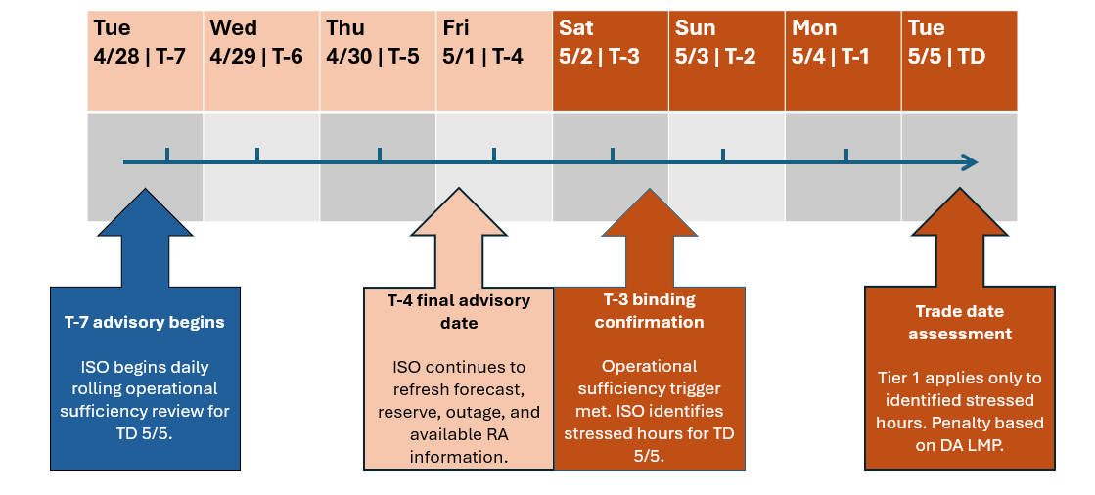

Figure 14 illustrates how the Tier 1 advisory and binding confirmation process would apply for a single trade date. For Tier 1, the non-availability charge would be based on the applicable day-ahead LMP for each identified stressed hour. In effect, this design would apply the existing day-ahead energy market price signal as a non-availability charge for shown RA capacity that is not available during the identified stressed hours. This price signal is intended to incent resources to be available including returning from outage or procuring substitute capacity before the applicable trade date and before the EDAM resource sufficiency evaluation is performed.
Tier 1 historical lookback
To provide context on potential Tier 1 frequency and timing, the ISO reviewed historical short-term forecast alerts during June through September in 2023-2025, covering hours ending in 19-21 as previous alerting focused on peak hours. The summary distinguishes alert-hour instances from unique operating dates by consolidating repeated alerts for the same date. If hour 19 for the same trade date alerted each day from T-7 to T-1, this counts as 7 alert-hour instances, but one unique operating date. This review illustrates how frequently operational forecasts identified elevated reliability risk in advance of the trade date during summer operations.
Figure 15 compares operating dates flagged 1-7 days ahead with those also flagged within 1-3 days of operation. The broader window captures the full set of flagged dates, while the shorter window shows how often potential reliability concerns were identified closer to the trade date. Most flagged dates also appeared in the shorter window, rather than only in forecasts issued farther in advance.

Figure 15: Historical forecast alert activity, 2023-2025
Year | Alert-hour instances | Unique operating dates alerted 1-8 days ahead | Unique operating dates also alerting 1-3 days ahead
2023 | 123 | 22 | 18
2024 | 124 | 23 | 20
2025 | 2 | 2 | 2
The results show substantially more alert activity in 2023 and 2024 than in 2025, illustrating that assessment frequency would vary with system conditions rather than follow a fixed schedule or minimum number of hours. These historical observations provide context for the proposed framework; financial assessment would apply only to the specific hours confirmed in T-3 to T-1.
Tier 1 pricing and external supply premium benchmark
The ISO continues to propose the applicable day-ahead LMP as the Tier 1 non-availability rate but seeks feedback on alternatives. This approach applies the existing day-ahead energy price signal to shown RA that is unavailable during identified stressed hours, encouraging resources to return from outage or procure substitute capacity before the applicable trade date.
Stakeholders have proposed Reliability Capacity Up (RCU) prices as a short-term capacity price alternative. The ISO recognizes its connection to operational availability but is concerned about whether an unadjusted RCU rate would provide a sufficient incentive under the proposed Tier 1 assessment framework. RCU procurement reflects the additional capacity needed relative to physical supply already cleared in the integrated forward market. Early EDAM performance reporting shows reliability capacity prices frequently near zero and, in the May report, generally below energy prices. These observations raise concern that directly adopting RCU could produce limited non-availability charges.
To provide an additional reference for evaluating the proposed rate, the ISO compared external bilateral hub prices with regional CAISO day-ahead price on the 100 highest-load days since 2022. The difference is described as the external supply premium benchmark:
$$External supply premium benchmark=External bilateral hub prices-Match CAISO DA LMP$$

As the RAAIM Tier 1 design is specifically focused on incenting availability when conditions are tight, but not necessarily in shortage conditions, a “capacity” price such as from RCU might not capture the right level of incentive during these periods. This benchmark represents the additional price of external supply relative to energy within CAISO for the same delivery period. By subtracting the internal energy price reference, the comparison provides an indicative premium associated with securing external supply and the potential opportunity cost of purchasing capacity during such periods. The ISO uses this premium to inform the discussion of short-term availability value, rather than as a directly observed price for bilateral RA capacity.
Figure 16: Bilateral hub and CAISO day-ahead price distributions on select high-load days.
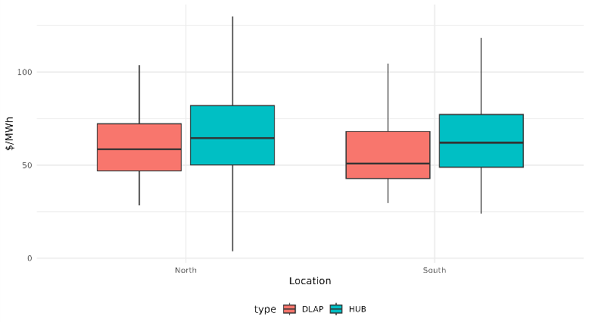
Figure 16 establishes the underlying price levels. The central ranges of the internal and external price distributions overlap, with higher bilateral hub-price medians in both regions. Figure 17 presents the matched price differences, which averaged approximately $13/MWh in the North and $16/MWh in the South, with substantially larger positive spreads in some observations.

Figure 17: External bilateral hub prices minus matched CAISO day-ahead prices.
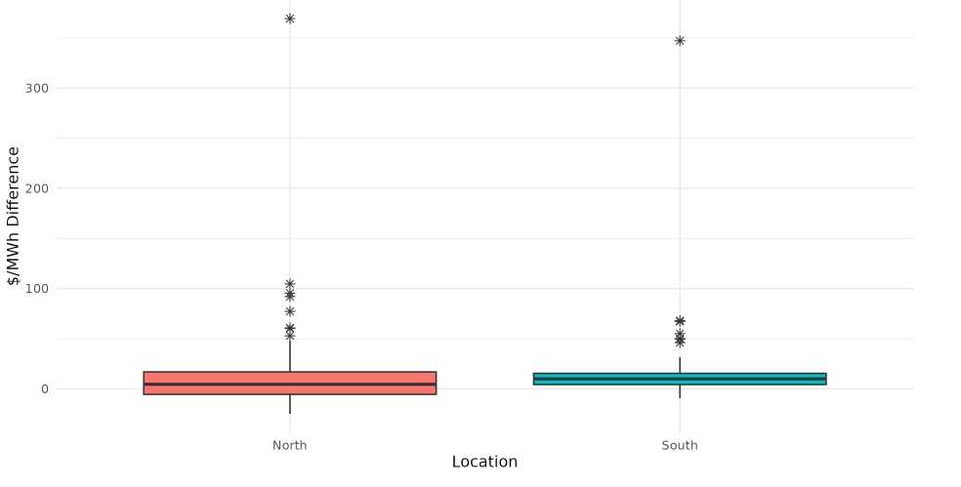
The spread distribution contains relatively modest central premiums, substantially larger positive observations, and some negative values. In both regions, median day-ahead prices can represent a multiple of the median external-supply premium. This comparison provides a reference for calibrating the Tier 1 rate. The full LMP is often higher than this potential estimate of a capacity value and as such there could be a justification for adopting the full LMP or a specified percentage of the LMP. The ISO seeks feedback and discussion on whether the LMP should be scaled or if a different calculation based on the capacity value could be scaled to provide an effective Tier 1 incentive.

Tier 2 - Critical Capacity Insufficiency Condition
- Purpose: incentivize RA resources to be available when they are needed most – during the tightest capacity conditions.
- Trigger: when the CAISO BAA fails the EDAM resource sufficiency evaluation category associated with insufficient upward capacity
- Evaluation: compare each resource’s shown RA against applicable bids in the deficient day-ahead upward interval, subject to the resource type applicability, outage, and availability rules described in the preceding section.
- Penalty price: $2,000/MWh

The RAAIM Tier 2 charge and the EDAM RSE failure charge are connected but ultimately designed to address distinct reliability objectives, even when both arise from an event involving insufficient capacity. While a resource's unavailability may contribute to both assessments, the two mechanisms serve different purposes and are based on different principles.
The RAAIM Tier 2 charge is intended to provide a standardized reliability incentive by reflecting the cost of failing to provide resource adequacy capacity when that capacity is needed for system reliability. In contrast, the EDAM RSE failure charge for a load that fails the EDAM Resource Sufficiency Evaluation (RSE) has a cost structure that varies and depend on factors beyond the quantity of unavailable RA capacity. The fixed Tier 2 charge may differ from the amount that would result if total EDAM RSE failure costs allocated to the CAISO BAA were divided among the unavailable shown RA MW assessed under Tier 2. To understand how that hypothetical calculation, which we term a “RSE penalty-based charge” relates to the proposed fixed $2,000/MWh value, we consider two different scenarios:
- $2,000/MWh may be less than the RSE penalty-based charge when the shortage occurs during highly stressed system conditions with significant scarcity costs reflected in hub prices or when the unavailable RA represents a relatively small share of an event that produces substantial system-wide reliability costs.
- Conversely, $2,000/MWh may be greater than the RSE penalty-based charge when other resources are available to offset the deficiency, such that the unavailable RA constitutes a large portion of the deficient capacity, but the overall operational consequences remain modest.
A principal benefit of maintaining a fixed Tier 2 charge is predictability and incentive stability. The fixed design avoids tying compliance incentives to potentially volatile prices. The fixed price of $2000/MWh would ensure that the incentive reflects a meaningful amount of the reliability value of RA capacity rather than the specific operational costs incurred during a particular event.
Tier 2 applies during the most acute capacity conditions, when the CAISO BAA has not demonstrated sufficient upward capability to meet its EDAM obligations. In these hours, incremental RA availability is particularly valuable because additional bid-in capacity may help avoid or reduce the consequences of an EDAM RSE failure.
For purposes of the settlement examples below, the Tier 2 RAAIM charge is illustrated as:
$$Tier 2 RAAIM Charge=RA Shortfall MW*\frac{\$2,000}{MWh}*Assessment Hours$$
where RA shortfall MW is the difference between the resource’s shown RA obligation and its day-ahead bid MW in the deficient hour.
Figure 18: Illustrative example of proposed net RSE exposure depending on bilateral trading hub price spread.
Scenario | Max Mid-C / Palo Verde Price | CAISO LMP credit | RSE surcharge | Tier 2 RAAIM charge | Net RSE exposure
Low hub-price spread | $30/MWh | $21/MWh | $15,469 | $40,000 | -$24,531
High hub-price spread | $250/MWh | $21/MWh | $345,469 | $40,000 | $305,469
Illustrative assumptions: 93.75 MW adjusted RSE deficiency, 16-hour on-peak strip, one on-peak RSE failure hour, 15 hours receiving LMP credit, 20 MW RA resource shortfall.
Figure 12 illustrates how the EDAM RSE surcharge can vary with external hub prices, while the Tier 2 RAAIM penalty remains fixed for the same RA shortfall. In the EDAM RSE surcharge calculation, the CAISO LMP credit is the applicable load-weighted average CAISO day-ahead LMP, which is subtracted from the Mid-C or Palo Verde reference price. The examples hold the RSE quantity and RA shortfall constant to isolate the effect of the Mid-C / Palo Verde price relative to the CAISO LMP credit.

Penalty Revenue Allocation & Bounded Exposure
The ISO proposes maintaining the self-funding element of the availability incentive payment process but modifying the allocation of collected non-availability charges to align with the revised event-based RAAIM framework. The availability standard would no longer be set between 94.5 percent and 98.5 percent of the monthly assessment period. Instead, non-availability charges would be calculated and allocated on a per-event basis.
For Tier 1, collected non-availability charges would be allocated to load and eligible available RA resources using a common per-MW allocation rate. Eligible available RA would consist of the portion of each resource’s shown RA determined to be available during the applicable Tier 1 assessment hours. Eligible MW would be capped at shown RA. If a resource is only partially available, the unavailable shown RA MW would be assessed the Tier 1 charge and excluded from the allocation base, while the available shown RA MW would remain eligible for an allocation.
This approach provides an additional incentive for each MW of shown RA to be available during stressed hours, beyond simply avoiding the non-availability charge. It also recognizes partial availability by charging the unavailable portion while allocating revenues to the portion that remains available. Including load in the allocation recognizes that customers fund RA procurement and may bear additional reliability-related costs when procured capacity is unavailable.
The ISO would calculate the per-MW allocation rate by dividing total Tier 1 charges collected for the event by the combined MW of load and eligible available RA during the applicable Tier 1 assessment hour. Each recipient’s allocation would then equal its MW share multiplied by the common per-MW allocation rate.

Figure 19A: Illustrative example of system-wide penalty revenue allocation
Settlement Step | Calculation | Result
Tier 1 non-availability MW |  | 10MW
Tier 1 price | Day-ahead LMP | $100/MWh
Tier 1 charge collected | 10 MW * $100/MWh | $1,000
Load during Tier 1 hour |  | 45,000 MW
Eligible available RA during Tier 1 hour |  | 50,000 MW
Total allocation base | 45,000 MW+50,000 MW | 95,000 MW
Per-MW allocation rate | $1,000/95,000 MW | $0.0105/MW
Load allocation | 45,000 MW * $0.0105/MW | $473.68
Eligible available RA allocation | 50,000 MW * $0.0105/MW | $526.32
Total |  | $1,000

Figure 19A illustrates the system-wide allocation of Tier 1 revenues for a simplified one-hour event. Because eligibility is determined on a per-MW basis, a partially available resource may be assessed a charge on its unavailable shown RA MW while the portion that remains available stays eligible for the common per-MW allocation. Figure 19B illustrates this treatment for an individual resource.
Figure 19B: Illustrative Settlement treatment of a partially available resource
Settlement Step | Calculation | Result
Shown RA |  | 100 MW
Available shown RA |  | 95 MW
Tier 1 shortfall | 100 MW – 95 MW | 5 MW
Non-availability charge | 5 MW * $100/MWh | $500
Eligible RA allocation quantity | 95 MW * per-MW allocation rate | $0.9975

In this example, the 5 MW shortfall would be assessed the Tier 1 non-availability charge, while the remaining 95 MW would remain in the eligible available RA allocation base. The resource’s payment for those 95 MW would be calculated using the common per-MW allocation rate shown in Figure 19A.
This MW-based approach provides more proportional treatment than the current monthly RAAIM framework. The current design averages availability across the month and applies a deadband, which can allow availability during lower-risk hours to offset a shortfall during a critical hour. Under the proposed event-based design, each unavailable MW would be charged during the applicable stressed hours, while each available shown RA MW would remain eligible for an allocation. This helps us eliminate some of the current challenges with including a deadband for resource performance and some of the inequities that could arise if the allocation was all or nothing for a resource to be eligible for a share of the allocation.

For Tier 2, we are proposing an identical structure as Tier 1 but also recognized that some stakeholders advocated that collected non-availability charges could be treated separately due to being tied to the EDAM RSE failure. Tier 2 revenues could be used to offset these failure costs allocated to the CAISO BAA. If Tier 2 collections are less than the applicable EDAM RSE costs, remaining costs could continue to be allocated under applicable EDAM settlement rules. In some circumstances, Tier 2 collections may exceed the applicable EDAM RSE costs allocated to the CAISO BAA.
Thus, in addition to the common per-MW allocation proposed above, the ISO seeks feedback on whether an alternative that would direct Tier 1 revenues to eligible available generation and Tier 2 revenues to load would be appropriate. This approach would use Tier 1 payments to reinforce resource availability during forecasted stressed conditions, while Tier 2 payments would recognize the RSE-related costs borne by load. The ISO looks forward to a discussion on whether this distinction would better align revenue allocation with the functions of the two-tier framework.
Bounded Monthly Penalty Exposure
The ISO proposes a staged framework to provide greater predictability in monthly penalty exposure while maintaining an availability incentive after an initial full-rate threshold is reached. Each resource’s Tier 1 and Tier 2 charges would accumulate toward a single set of monthly thresholds based on the CPM soft-offer cap.
Charges would initially be assessed at the full applicable Tier 1 or Tier 2 rate until cumulative charges reach the resources monthly amount corresponding to 100% of the CPM soft offer cap. Additional charges would then be assessed at 20% of the otherwise applicable rate until total assessed charges reach a hard cap of 200% of that monthly amount.
Figure 20: Bounded penalty exposure summary table
Penalty stage | Cumulative monthly Tier 1 and Tier 2 charges | Rate applied
Full-rate stage | Up to 100% the CPM-based monthly amount | 100% of the applicable Tier 1 or Tier 2 rate
Residual stage | Above 100% and below 200% the CPM-based monthly amount | 20% of the otherwise applicable rate
Hard cap reached | At 200% CPM-based monthly amount | No additional charges for the remainder of the month
The reduced rate would preserve an incentive to restore availability after the full-rate threshold is reached, while the hard cap would establish a predictable maximum monthly exposure. Cumulative exposure would reset at the beginning of each month, with no carryover towards the following month’s thresholds. This structure would limit dollar charges without reinstating monthly availability averaging or allowing availability in other hours to offset an assessed shortfall.
Assume a 50 MW resource with its full capacity shown as RA throughout the month. All 50 MW is unavailable during 10 Tier 1 hours with an assumed day-ahead LMP of $100/MWh, and during 24 separate Tier 2 hours assessed at $2,000/MWh.
Using a CPM reference of $7.34/kW-month, the resource’s full-rate threshold would be $367,000. Furthermore, its hard monthly cap would be $734,000.
Figure 21: Bounded exposure illustrative example
Calculation step | Calculation | Amount
Tier 1 charges before exposure limits | 50 MW * $100/MWh * 10 hours | $50,000
Tier 2 charges before exposure limits | 50 MW * $2,000/MWh * 24 hours | $2,400,000
Combined charges before exposure limits | $50,000 + $2,400,000 | $2,450,000
Charges assessed at the full rate | Up to the 100% CPM threshold | $367,000
Reduced-rate charges before applying the hard cap | 20% * ($2,450,000-$367,000) | $416,600
Total after the rate reduction, before the hard cap | $367,000 + $416,000 | $783,600
Final monthly charge | Limited to the 200% CPM hard cap | $734,000

RAAIM reform as complement to LRA QC methodologies
Given the CPUC’s current UCAP implementation path for a substantial portion of RA resources, the key question becomes what, if any, incremental incentives are necessary to ensure operational availability. UCAP and revised RAAIM serve related but distinct functions. UCAP reflects historical availability in forward counting values, while revised RAAIM would assess whether shown RA capacity is available in the operational timeframe. In this way, UCAP improves the forward planning value assigned to a resource, while revised RAAIM provides an operational incentive for that shown capacity to be available when the ISO is relying on it.
RAAIM should be reformed to strengthen the operational availability incentive for shown RA during stressed hours. Energy and reserve prices provide market-wide signals reflecting system conditions, but they do not directly determine whether capacity procured and shown as RA met its availability obligation. Revised RAAIM would complement those market signals by applying targeted non-availability charges to shown RA that is unavailable during Tier events. The proposed penalty levels are intended to provide a more meaningful availability inventive than current RAAIM without attempting to replicate the full reliability cost of load curtailment or reserve shortages.
The ISO recognizes stakeholders’ concerns that the same outage could affect a resource’s future UCAP accreditation value and also create revised RAAIM exposure if the outage occurs during a Tier event. The ISO views these consequences as addressing different reliability functions. A UCAP derate affects the amount of capacity credited to the resource in a future forward RA showing, while revised RAAIM would apply only when shown RA capacity is unavailable during a specific operational assessment hour, subject to applicable outage, substitution, and resource-specific treatment. This distinction preserves UCAP’s role in forward accreditation while maintaining an operations availability incentive during the hours when reliability risk is elevated.
In doing so, this proposal aims to create stronger incentives for resources to take actions that improve availability, including performing maintenance (both normal short-term maintenance and capital upgrades) in advance of tight conditions, returning from outages more quickly, and avoiding what could be discretionary outages during periods of system stress.
CAISO is continuing to advance the Track 2 must-offer obligation and RAAIM design work through this initiative. At the same time, CAISO is conducting a broader review of its resource adequacy-related processes and procedures in light of stakeholder feedback regarding the CPUC's UCAP framework. As part of that effort, CAISO is examining how capacity values are used across a range of processes, including RA showings, must-offer obligations, RAAIM, local requirements, exports, and deliverability studies, as well as the potential implications of alternative approaches.
CAISO appreciates the perspectives stakeholders have provided to date and welcomes additional feedback on these and related issues. While CAISO has identified a number of questions that warrant further evaluation, the review remains ongoing. CAISO does not currently see these questions as impairing the effectiveness of those processes in supporting resource adequacy and reliability objectives. Nevertheless, stakeholder input will be an important component of developing a more complete understanding of the commercial and policy considerations associated with these issues.
The outcome of this review will help inform future stakeholder engagement and provide greater clarity regarding how existing processes interact with a UCAP framework, as well as whether additional process refinements should be considered. CAISO also recognizes that, given the interaction between Track 2 and the CPUC's UCAP framework, further coordination between the two efforts may be beneficial as they continue to evolve.

Flexible Resource Adequacy and RAAIM
Throughout the RAMPD working group process and policy development, the ISO has recognized that reforms to its various program elements, including potential changes to RAAIM, should be evaluated in the broader context of both System (generic) and Flexible (flex) RA. Today, RAAIM applies to both generic and Flexible RA capacity, but those two products use different availability assessment hours and penalty constructs. As the ISO enhances the System RA availability incentive framework to focus on identified stressed hours and critical capacity insufficiency conditions, maintaining the existing Flex RA penalty framework could create overlapping or poorly aligned availability incentives for the same resources.
The ISO is continuing to evaluate the longer-term role of Flex RA, including whether the program should be retained, redesigned, or retired as market products and RA contracting and procurement evolve. In the interim, the ISO proposes to retain the Flex RA showing requirements and associated must-offer obligations, while suspending Flex RA-specific RAAIM penalties during a transitional period. This interim approach preserves the procurement and operational visibility functions of Flexible RA, while avoiding a separate Flex RA penalty construct that may not align with the enhanced System RA RAAIM framework. This approach is intended to allow the System RA RAAIM reforms to move forward without requiring parallel redesign of Flexible RA in the same initiative.
The ISO will continue to assess the future of Flex RA through a separate analysis and stakeholder process. That process will consider whether a Flex RA performance mechanism should be reinstated, redesigned, or eliminated, and whether any longer-term Flex RA framework should be aligned with the enhanced System RA availability incentive design. During the transition period, the ISO will monitor whether suspending Flex RA-specific penalties creates operational or bidding concerns that require further action.

Performance Assessment
The ISO is not proposing a new performance incentive mechanism as part of this revised straw proposal. Revised RAAIM is focused on availability – whether shown RA capacity is made available through applicable bids, schedules, and outage status during identified assessment hours. A performance mechanism would address separate questions on whether a resource ultimately is available in real time and performs consistent with the schedule or dispatch instruction it receives.
Comments on the May 2026 straw proposal reflected different views on whether and how a complementary performance mechanism should be developed. DMM continued to recommend a performance incentive that would complement the availability framework, while other stakeholders raised questions about whether performance should be addressed only for RA resources or as a broader market issue. The ISO therefore proposes to address the design of any performance mechanism through future policy development rather than as part of the current revised RAAIM proposal.
Any future performance framework would need to account for differences across resource types, systems conditions, dispatch instructions, deliverability constraints, and other operational limitations that may affect a resource’s ability to perform. That work would also need to determine whether a performance incentive should apply only to RA resources and shown RA capacity or more broadly to resources receiving market awards.

3 Bidding Requirements for System RA Resources

Problem Statement and Objectives
As LRA accreditation methodologies evolve, the relationship among a resource’s NQC, shown RA, operating capability, and MOO requires greater clarity. The following problem statement frames the issue addressed in this section:
The existing system RA bidding framework may not preserve the intended MOO when a dispatchable resource’s accreditation value is lower than its operating capability. If the MOO is set directly equal to shown RA, an accreditation derate may reduce the capacity visible to the ISO market even where the resource remains capable of offering additional capacity. The framework also needs to provide clear treatment for:
- Resources that are only partially shown as RA or have partial capacity deliverability status;
- Resources shown under multiple LRA programs; and
- The distinction between MOO, revised RAAIM exposure, and substitute capacity requirements
The ISO’s objective is to develop a MOO framework that addresses the following:
Operational visibility: The framework should preserve visibility into the operating capability associated with a dispatchable resource’s RA showing.
Consistent application: The methodology should remain workable as LRAs use different accreditation approaches and should rely on values established through the existing CAISO RA process.
Proportional treatment: The bidding obligation should scale with the portion of the resource shown as RA, including for partially shown partial capacity deliverability status (PCDS) resources.
Clear separation of obligations: The MOO would establish the applicable bidding obligation, while revised RAAIM charges and substitute capacity requirements would continue to be based on a shortfall below shown RA.

Stakeholder Feedback

Feedback on the May proposal emphasized distinguishing statistical accreditation values from daily operating capability. DMM supported aligning the MOO with the operational capability associated with shown RA under both UCAP and non-UCAP methodologies. In comments on the July revised straw proposal, PG&E and DSG&E emphasized consistent translation between accreditation values and bidding obligations across LRA programs. Cal Advocates and CPUC Energy Division also recommended an LRA role in providing MOO values.
Deliverability informed recommendations from AES, WPTF, MRP, and Vistra to base bidding obligations on deliverable RA capability rather than unconstrained Pmax. These recommendations sought to preserve access to capability associated with the RA showing without extending obligations to energy-only or non-deliverable capacity. CDWR, NCPA, and Six cities instead favored limiting the MOO to shown RA, citing contractual commitments, with CDWR also emphasizing the availability of additional capacity for substitution.
The distinction between bidding obligations and RAAIM exposure remained important even where stakeholders supported MOO refinements. AES, NextEra, and SDG&E supported retaining shown RA as the assessment basis when the MOO exceeds that quantity. CalCCA instead favored assessing RAAIM against the MOO to encourage resources to satisfy their full bidding obligation, with CPUC Energy Division aligning with that approach.

Bidding Requirements

The ISO proposes to determine the MOO for dispatchable system RA resources using the relationship among shown RA, NQC and the resource’s deliverable portion. For purposes of this proposal, the deliverable portion refers to the portion of resource output that can be delivered to aggregate load on the CAISO controlled grid, consistent with the CAISO’s Reliability Criteria and Procedures and the CAISO On-Peak Deliverability Assessment. For example, a resource with 100 MW Pmax and 75 percent deliverability would have a maximum bidding obligation of 75 MW.
NQC establishes the maximum capacity that may be shown as RA. The deliverable portion and NQC may have the same MW value, but NQC may be lower where an accreditation derate reduces the RA counting value without a corresponding reduction in deliverable portion of the resource. The proposed approach would preserve the proportional relationship between shown RA and the deliverable portion as accreditation methodologies evolve.
The MOO would define the quantity the resource must make available through applicable bids or schedules, subject to applicable outage and resource -type bidding rules. Revised RAAIM charges and substitute capacity requirements would remain based on the resource’s shortfall below shown RA and would not increase because MOO exceeds shown RA.
This framework would apply to dispatchable system RA resources. It would not establish a conventional MOO for VERs or replace bidding and availability obligations governed by separate tariff, forecast, or program-specific rules.

Application of the Proposed MOO Framework
The proposed calculation retains the July framework’s proportional treatment of full and partial showing, while using the deliverable portion in place of Pmax. This refinement would leave the calculated MOO unchanged where the deliverable portion equals Pmax.
A resource may be shown under multiple LRA programs that use different QC methodologies. The existing NQC process resolves those LRA-specific QC inputs and establishes a single monthly NQC value for the resource before RA showing and MOOs are determined. The NQC is determined based on the LRA with the highest QC. That NQC value is used in the CAISO RA process and sets the maximum total RA that may be shown for the resource. The ISO therefore proposes to use the resource’s final NQC, total shown RA in the CAISO BAA, and applicable deliverable portion in the MOO calculation, rather than calculate separate MOO values for each LRA driven QC.
To address these different resource configurations, the ISO will use the defined MOO in the preceding subsection. The calculation would scale the resource’s bidding obligation in proportion to its shown RA through the following formula:
$$\text{must-offer obligation (MW)}= shown RA \left(MW\right)× \frac{Deliverable Portion [Pmax \left(MW\right)*Deliverable \left(\%\right)]}{NQC (MW)}$$

Figure 22: Examples of proposed MOO based on NQC, deliverable portion, and shown RA
Resource | Pmax (MW) | Deliverable portion (MW) | NQC (MW) | Shown RA (MW) | MOO (MW)
Plant 1 | 100 | 100 | 90 | 90 | 100
Plant 2 | 100 | 100 | 90 | 45 | 50
Plant 3 | 100 | 50 | 45 | 45 | 50
Plant 1 shows its full NQC, resulting in a MOO equal to its 100 MW deliverable portion. Plant 2 shows half of its NQC, resulting in a proportionally reduced MOO of 50 MW. Lastly, plant 3 shows its full NQC, but its partial deliverability results in a MOO of 50 MW rather than its unrestricted 100 MW Pmax.
The shown RA value for these resources would continue to be limited by the applicable QC or accreditation value, including any derates reflected through UCAP or other LRA counting methodologies. The purpose of the MOO calculation is to preserve ISO visibility into operational capability where a resource’s accreditation value is below its physical operating capability. However, the ISO proposes that revised RAAIM exposure and outage substitution obligations remain based on shown RA. Applying RAAIM to the higher MOO quantity would introduce implementation and policy complexity, including how to account for operating limitations, such as ambient derates, that already be reflected in the resource’s counting value.
If a resource offers less than its shown RA during an applicable assessment hour, the RAAIM shortfall and any substitution obligation would be measured against shown RA. If a resource offers at least its shown RA but less than its MOO, the resource will not incur revised RAAIM penalties for the MW above shown RA. As is the case today, the tariff-defined MOO will apply more broadly than RAAIM. Absent a properly-reported outage to the CAISO’s outage management system, the tariff will continue to obligate scheduling coordinators to submit offers for all MWs subject to an RA MOO regardless of RAAIM exposure.

4 Outage Substitution Enhancements for RA Resources

Problem Statements and Objectives
As a part of the RA Modeling & Program Design working groups that began in fall 2023, the following sub-issue was identified as a part of the greater RA problem statements:
The ISO’s existing outage substitution mechanisms should be reassessed. Both initial analysis and working group feedback indicate that the current processes and procedures likely result in:
- Inefficiencies as multiple SCs hold back RA capacity for outage substitution for a partial-month outage.
- Artificial tightness in the RA bilateral market due to holding back capacity for outage substitution.
- Potential maintenance delays if substitute capacity is not available.
- Higher forced outage rates because planned outages cannot be scheduled and the resource ultimately experiences a forced outage.

To address the problem statement above, CAISO aims to enhance the RA capacity substitution process to meet the following attributes:

Efficient: The process should be efficient so that capacity is available to substitute without significant effort by participants or exceptions to the RA substitute capacity process.
Reliable process for resources: The process should promote reliability by allowing resources to perform needed maintenance to reduce future forced outages and reliability events at the ISO.
Reliable process for CAISO: After factoring in resources on planned outage, there should be sufficient capacity to reliably operate the grid.
Incent showing resources: CAISO’s process should not incentivize individual scheduling coordinators to hold back substitute capacity for their own needs as it creates a tighter RA market, limited substitution opportunities for other scheduling coordinators, and reduces the visibility CAISO operators have to available capacity. Similarly, the RAAIM and MOO requirement should not create risks or uncompensated burdens to an LSE showing resources beyond what is needed for reliability. LSE contracted resources should be visible and operational to the market. There should be efficient processes for potential non-contracted resources to be available as substitute capacity.
Alignment with LRA programs: The ISO seeks alignment with LRAs on any outage and substitution policies. The ISO would also like better insight into whether any LRA planning reserve margins account for planned outages.

Stakeholder Feedback
In August 2025, the ISO issued a straw proposal related to outage substitution reforms for RA resources. ISO stakeholders are generally in agreement that the current outage substitution management processes need to be improved. The goal is to have outage management processes that are more efficient and reliable, particularly given a recently tight RA market and the importance of timely maintenance so resources can remain dependable and fully operational.
The August 2025 straw proposal, consistent with stakeholder feedback in the working group, explored options for an outage substitution pool, and included a recommended approach for a decentralized substitute capacity pool that functions like an open marketplace for peer-to-peer transactions of substitute capacity between scheduling coordinators. The proposal also reviewed two alternative approaches to enhance the substitute capacity procurement process that the ISO did not recommend. Both of these involved the ISO matching buyers and sellers by clearing bids in an auction and, in the absence of a standardized substitute capacity product with defined duration and MW value, prioritizing either the highest bid price for capacity (Alternative 1) or the largest outages by MW (Alternative 2).

Stakeholder feedback on the August 2025 meeting generally supported improving the visibility and transactability of substitute capacity but reflected different views on the appropriate level of ISO involvement. Some stakeholders supported the decentralized “shopping cart” approach as an implementable improvement to the existing bilateral process, while others preferred or encouraged the ISO to continue evaluating a more centralized or optimized matching mechanism. Stakeholders also requested additional detail on the information displayed in the platform, the duration and granularity of available products, and how the proposed tool would improve upon the existing bulletin board.
Comments on the May and July 2026 straw proposals similarly focused on whether the proposed workflow would materially reduce the search and coordination frictions that limit substitution today. The CPUC Energy Division and various load serving entities supported the enhancements towards a voluntary substitute capacity pool in concept. However, other stakeholders including Vistra, California Energy Storage Alliance (CESA), and Middle River Power indicated that the proposed enhancements would not meaningfully address the problem statements above. CESA and the Western Power Trading Forum recommended the ISO work toward a more centralized, ISO-administered substitute capacity procurement process. DMM requested that the ISO more clearly explain how the shopping cart approach would address the reasons entities do not currently procure replacement capacity, particularly given the time and resources required to develop the tool.
Stakeholder feedback generally supported efforts to improve visibility into available substitute capacity, but comments have reflected differing views regarding the appropriate amount of information that should be displayed through the platform. Some stakeholders, such as WPTF, indicated that greater transparency regarding available substitute capacity could improve transaction efficiency and reduce search costs. San Diego Gas & Electric expressed concerns that publication of commercially sensitive information could reveal procurement strategies, negotiating positions, or other confidential market information. Stakeholders also noted that preserving confidentiality in some areas may reduce the usefulness of the platform if insufficient information is available to facilitate transactions. In addition, Vistra and AES questioned whether transparency alone would address the underlying challenges associated with outage substitution, particularly in periods when substitute capacity is scarce.
The ISO has considered this feedback in further developing the transaction workflow described below.
Stakeholders have also supported allowing planned maintenance outages without substitution when system conditions do not present reliability risk. The ISO is not proposing to unconditionally approve planned (and, per section 5, opportunity) outages without substitute capacity because monthly RA showings and applicable planning assumptions do not account for all planned outages. Instead, the proposed shopping cart workflow is intended to reduce the burden of finding and transacting for substitute capacity where substitution remains required.

Outage Substitution Enhancements: Shopping Cart Approach

The ISO proposes to continue development of the decentralized "shopping cart" approach described in the August 2025 straw proposal as a structured transaction workflow rather than a simple contact board. Sellers would post RA-eligible substitute capacity through a tool within CIRA, and scheduling coordinators seeking substitute capacity would identify and select offers through a tool designed to reduce the search and administrative burden associated with existing bilateral substitution arrangements. Following confirmation from both parties, the ISO would remove the sold capacity from the available pool and apply the substitution through the resource adequacy substitute capacity (RASC) process. Contracting and financial settlement would remain bilateral and outside the ISO’s purview.
The proposed tool is intended to reduce search and transaction friction through a common selection and confirmation process in advance of the RASC process. The shopping cart would not create a centrally cleared ISO market, establish a market-clearing price, or require the ISO to optimize or in any way match buyers and sellers.
The current process for providing substitute capacity in CIRA for outages on RA capacity shows a “planned substitute resource selection” screen. This screen provides a list of any and all available resources in CIRA that are not fully shown on a supply plan for the period of the outage (see Figure 23). These available resources are displayed based on the difference between their NQC and their current RA capacity. It is the responsibility of SCs seeking substitute capacity for a planned outage on their own RA capacity resource to bilaterally contract with plant owners that have RA capacity available to substitute on this list. For a planned outage, after the SC searching for substitute capacity submits the substitution plan, the counterparty SC has twenty-four hours to approve the substitution. Effectively, this means that the contracting must be done before the SC submits the outage.
Figure 23: Planned substitute resource selection screen in CIRA
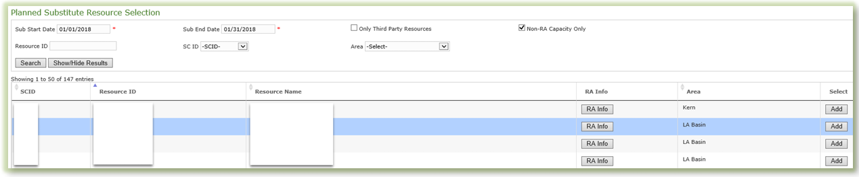
The shopping cart tool will display substitute capacity that is being actively offered into the shopping cart tool by SCs (instead of simply showing any and all partially or fully unshown RA resources, as in Figure 23). The offering SCs’ capacity will be posted for specified date ranges. Sellers can also indicate the MW quantity available for substitution and other transaction parameters. Buyers could then select the RA capacity needed to substitute their outage, subject to the seller's stated conditions and the applicable substitution requirements. Once they select the capacity, as soon as the offering SC approves the selection, the substitution will automatically be qualified through the RASC process.
Figure 24: Illustrative Shopping Cart Tool Screen
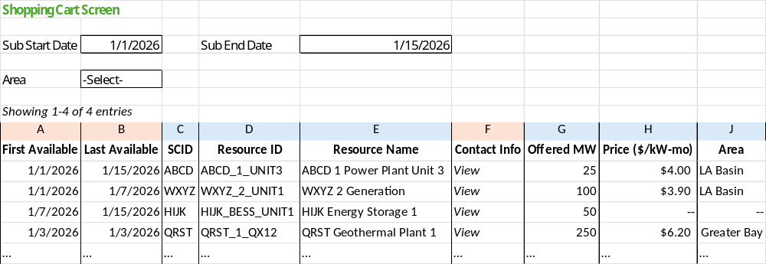

Figure 24 provides an illustrative example of the shopping cart tool screen. Columns A, B, C, D, E, F (if available), and J are already available in the ISO’s existing substitute resource selection screen (see Figure 23). The columns in orange (A, B, and F) represent fields that are the minimum information necessary for the shopping cart tool to be functional. The ISO recognizes that there are legitimate tradeoffs between increasing transparency to create a tool that can effectuate transactions and prevent unintended negative competitive consequences. Greater transparency may improve the usefulness of the shopping cart tool by making it easier for SCs to identify, evaluate, and procure available substitute capacity. At the same time, it may be necessary to mask certain fields to protect commercial information and avoid unintended competitive impacts. The ISO therefore seeks additional stakeholder feedback regarding what information should be displayed through the tool and whether certain information should be left to the offering SC to share directly once the buyer contacts them via the tool.
Per Figure 24, attributes identified for further consideration include the visibility of:
- Availability dates / duration
- Resource information
- Contact information
- Local area (if available)
- Offered MW quantities
- Identifiable counterparty information
- Offer price
The ISO is specifically seeking feedback on the display of these attributes in the tool such as identifiable counterparty information, offered MW quantities (daily MW values), and offer price. As discussed above, the ISO has not determined whether or not these attributes should be available to buyers through the tool. The fewer fields shown, however, the less the shopping cart tool will provide value relative to the ISO’s existing power contracts bulletin board, which allows market participants to post either detailed resource offerings or simply indicate general commercial interest to buy or sell. The ISO also intends to consider stakeholder views regarding potential confidentiality safeguards and any implications for the ability of SCs to exercise market power.
Based on the stakeholder feedback received to date and the relative implementation complexity associated with more centralized substitution procurement alternatives, the ISO continues to believe the decentralized shopping cart approach provides value. The proposal is intended to address the above problem statements: to reduce search and administrative friction for SCs seeking substitute capacity while preserving bilateral control over commercial terms. It provides an opportunity for more efficient bilateral contracting and offers incentives for SCs to offer their capacity through the tool instead of withholding it. These efficiency improvements, which could lead to more timely planned maintenance for RA capacity resources, will ultimately result in a more reliable ISO grid.

5 Outage Definitions

In the RAMPD working group process, the ISO received questions and feedback regarding the clarity of existing outage definitions and the timing requirements for submitting different outage types. The ISO proposes to distinguish planned, urgent, and forced outages based primarily on the operating condition of the resource, the reason for the outage, and whether the resource can remain in service while the outage is coordinated. In addition, the ISO is seeking feedback on adding three additional outage types to achieve full alignment with RC West rules: opportunity, informational, and operational outages.

Stakeholder Feedback
A broad cross-section of stakeholders argued that the short-notice opportunity outage RAAIM exemption serves an important reliability function by allowing RA capacity to perform short-duration maintenance when the ISO determines system conditions can accommodate the outage. These stakeholders generally contended that removing the short-notice opportunity outage exemption could discourage proactive maintenance, increase deferred maintenance, and ultimately contribute to more forced outages.
Stakeholders also raised concerns regarding the proposed urgent outage definition and its treatment relative to forced outages. Many commenters requested additional clarity regarding the distinction between urgent and forced outages, applicable timelines, outage-submission requirements, substitution obligations, and RAAIM exposure.
A smaller group of stakeholders expressed support for portions of the proposed outage-definition reforms. Across comments, a common theme emerged that the ISO should more clearly define the consequences associated with each outage type and demonstrate how revised outage classifications would interact with RAAIM assessments and substitution obligations.

Proposal
The table below is designed to clarify the uncertainties expressed by stakeholders in comments.
Figure 25: Generator Outage Definitions: Planned, Opportunity, Urgent, and Forced
Reason for going out of service or reducing capability | if notice can be given… | .. then.. | Proposed RAAIM and substitution treatment
The resource is out of service for routine maintenance or new construction | in time to meet the RC short notice study window submission deadline | it is a planned outage. | Must provide substitution via RASC to be approved
 | only after the RC short notice study window submission deadline (no sooner) | it is an opportunity outage. | Must provide substitution via RASC to be approved  (except if off-peak opportunity outage)
The resource carries an increased risk of forced outage and needs to go out of service when conditions allow | Prior to taking the outage with as much advance notice as possible | it is an urgent outage. | May provide substitution, otherwise exposed to RAAIM
The resource needs to go out of service with little to no notice | N/A | it is a forced outage. | May provide substitution, otherwise exposed to RAAIM

The ISO seeks to align the tariff’s outage definitions with the RC West outage coordination framework, which distinguishes planned, urgent, opportunity, forced, informational, and operational outages and establishes related study and coordination timelines. This proposal uses those operational classifications as a model in order to seek alignment with reliability coordinator outage procedures, while separately defining the substitute capacity and revised RAAIM treatment associated with each generation outage type.
This revised straw proposal is also written to provide more clarity on outage submission timing in relation to the study and coordination processes.

Planned Outages
Today, planned (also known as maintenance) generation outages are defined as a period of time during which a generation operator limits the capability of a plant or takes it out of service for the purposes of carrying out routine planned maintenance, or for the purposes of new construction work.

Consistent with the RC West outage coordination framework, the ISO proposes to define a planned outage as an outage for maintenance or construction work that can reasonably be scheduled with sufficient advance notice to meet the applicable short-range study and coordination requirements. Planned outages would be submitted in accordance with the applicable RC West and CAISO outage coordination procedures. Planned outages on RA capacity will remain subject to substitution requirements through RASC—SCs must provide substitute capacity in order to have a planned outage approved for a resource providing RA capacity.

Urgent outages
This proposal introduces a new type of outage called an urgent outage. An urgent outage would apply when facility or equipment remains operable but carries an increased risk of a forced outage. The facility or equipment would remain in service until personnel, equipment, or system conditions allow the outage to occur.
A scheduling coordinator should submit an urgent outage as soon as it becomes aware of the condition. An urgent outage may be submitted before or after the applicable planned outage study-window deadline; timing alone would not determine the outage classification. The classification would depend on the operating condition of the facility and the need for the outage to occur in the near term. Urgent outages would be prioritized similar to forced outages for conflict resolution purposes.
An urgent outage should have a justification of its urgency documented in the balancing authority/transmission operator comments section of the outage submission. Under the ISO’s default qualifying capacity methodology, urgent outages would count towards a unit’s UCAP-based QC value just as forced outages do. A plant on an urgent outage would also be subject to revised RAAIM penalties, as urgent outages would be considered equivalent to forced outages for availability purposes. Thus, urgent outages would not require replacement substitute capacity.

Forced outages
This proposal includes a new forced outage definition to clarify and distinguish the timelines for forced outages, urgent outages, and planned outages.
Today, a forced outage is defined as outage for which sufficient notice cannot be given to allow the outage to be factored into the day-ahead market or real-time market bidding processes. Today, any request for a maintenance outage that is submitted seven days or less prior to the outage start date is classified as a forced outage.
The ISO proposes a new forced outage definition to reflect that a plant needs to be removed from service in real time with very limited or no notice. Forced outages should be submitted as soon as the SC becomes aware that the unit is or will about to be offline. Today, the ISO sets requirements for notifying the control center in advance of a forced outage beginning, depending on how much notice the SC can give the control center. In a future with urgent and forced outages, the ISO would need to establish new outage notification and coordination guidelines to distinguish between forced and urgent outages consistent with the needs of CAISO BA operators.

Opportunity Outages
In response to stakeholder feedback that the short-notice outage RAAIM exemption provides a pathway for avoiding RAAIM exposure for legitimate preventive maintenance, the ISO proposes introducing an opportunity outage type. Opportunity outages also exist in RC West outage definitions. Opportunity outages would apply when a unit can be derated or taken out of service due to favorable system conditions, weather, or staffing availability to perform routine maintenance or construction work after the short-range study deadline has passed. Per RC West procedures, opportunity outages should have an emergency return time of no greater than eight hours.
Although RC West procedures allow opportunity outages to be submitted immediately before the outage start time, the ISO proposes treating them the same as planned outages for RAAIM and substitution purposes. Opportunity outages on RA capacity would therefore require substitute capacity through the RASC process and must be submitted by the morning two days before the outage start date to allow 48 hours for substitution and ISO validation. Consistent with the treatment of planned outages, opportunity outages should not count toward a unit's UCAP-based qualifying capacity value in the ISO’s default qualifying capacity methodology, and should be considered fully substituted for the purposes of developing the ISO’s default planning reserve margin.
This proposal retains the off-peak opportunity outage RAAIM exemption that provides a route for RA resources to take an opportunity outage without needing to provide replacement capacity. Off-peak opportunity outages help preserve flexibility for maintenance of RA resources during CAISO-determined low-risk hours since these outages do not require substitute capacity and can be submitted with enough advance notice to be studied. The RAAIM exemption requires off-peak opportunity outages to be submitted no later than eight days prior to the start date for the outage. This limit should remain in order to give enough time for the outage to be studied. Today, the low-risk hours during which off-peak opportunity outages can occur include weekdays from hour ending 23 to hour ending 06 and all day on Saturdays, Sundays, and holidays.
The proposal eliminates the short-notice opportunity outage category. This category could cause confusion with the proposed urgent and opportunity outage definitions and creates additional complications for outage study timelines.
Short-notice opportunity outages can undermine the purpose of the resource adequacy program because they provide relief from penalties that are designed to encourage generation owners to plan ahead and undergo planned outages to perform the maintenance required to minimize forced outages. Generators should utilize planned maintenance within the outage study windows to ensure availability in the RA month. In addition to being redundant with the urgent outage definition, short-notice opportunity outages have the added complication of causing challenges with the outage study window timelines.

Informational and Operational Outages
In addition to the four outage types described above, the ISO proposes to incorporate informational and operational outage types into its processes to ensure full alignment in outage definitions with RC West, beyond just those used for generation availability. Because the informational outage does not derate a unit or take it out of service, there is no substitution/RAAIM impact. Similarly, for operational outages, which only impact transmission facilities, there is also no substitution/RAAIM impact.
An informational outage is a facility/equipment outage that is entered for informational reasons including increased situational awareness, for balancing authority or transmission operator internal purposes, or to satisfy RC data specifications.
An operational outage is when a transmission line is removed from service in the normal course of maintaining optimal or reliable system conditions but remains available if needed upon short notice.

6 Governing Body Role
This straw proposal includes proposed amendments to three categories of tariff rules: revised RAAIM; system RA must-offer and bidding requirements; and outage reporting and coordination. The decisional classifications described below are preliminary and will be confirmed as the specific tariff amendments are developed under the Charter for WEIM and EDAM governance.
Revised RAAIM provisions would apply only to CAISO balancing authority area RA resources and settlements. Because these provisions would not establish obligations for WEIM or EDAM entities or market participants in those capacities, ISO staff preliminarily expects the RAAIM amendments to fall outside of the WEM Governing Body’s primary authority. The final decisional role will be confirmed when the specific tariff amendments are developed.
The proposal also includes specific changes to system RA must offer and bidding requirements. Because these requirements would apply only to CAISO balancing authority area RA resources, ISO staff preliminarily expects them to fall outside the WEM Governing Body’s primary authority. To the extent the final tariff amendments establish or modify bidding requirements that apply in the day-ahead or real-time market, ISO staff preliminarily expects the WEM Governing Body to have an advisory role. The final classification will be confirmed when the specific tariff amendments are developed.
Outage-related amendments may require different decisional classifications depending on their scope. To the extent the final tariff amendments change outage reporting or coordination rules applicable to WEIM or EDAM balancing authority areas, entities, or market participants, those elements would fall within the WEM classification, while substitute-capacity and revised RAAIM treatment would remain outside primary authority.
These preliminary classifications reflect the current proposal and may be refined as the policy process moves forward. Stakeholders are encouraged to comment on the proposed classifications.

7 Next Steps
Please submit comments on this Revised Straw Proposal and the October 9, 2026 workshop by October 23, 2026 using the comment template on the ISO stakeholder website.

For example, if a number of resources are close to retirement or in need of major capital upgrades, a UCAP only incentive might not be sufficient and “real time” penalties might be more appropriate.
https://stakeholdercenter.caiso.com/InitiativeDocuments/Presentation-Resource-Adequacy-Modeling-and-Program-Design-Mar-03-2025.pdf
Does not include ambient derates due to temperature
See pages 53-62: https://stakeholdercenter.caiso.com/InitiativeDocuments/Issue-Paper-Resource-Adequacy-Modeling-and-Program-Design-Nov-07-2024.pdf
The forced outage data on the page above represents the worst outage of the day for a resource minus what was substituted on a daily basis which was later averaged over the number of days in that month.
CPUC Decision (D.) 26-07-008 adopts a UCAP framework beginning with the 2028 RA compliance. D.26-07-008 explains that certain implementation issues remain under development, including how UCAP-based values would interact with CAISO tariff and RA processes. For the purposes of this straw proposal, the CAISO will refer the resulting capacity value due to any urgent and forced outage-related derate to counting values – whether they apply in CPUC’s RA program, CAISO’s RA processes, or both – as “UCAP accreditation values”.
CAISO Tariff Section: 40.8.1.13. A Proxy Demand Resource must have the ability to (i) be dispatched for at least twenty -four hours per month, (ii) be dispatched on at least three consecutive days, and (iii) respond for at least four hours per dispatch in order to qualify as Resource Adequacy Capacity.
In both cases, assume the resource submits bids covering 100 MW in SIBR. Equipment derates are reported separately through the Outage Management System (OMS). Accounting for the reported derates leaves 90 MW available for the assessment in case A and 70 MW in case B; these quantities are not the original bid quantities submitted in SIBR.
D.21-06-029, p. 31.
DMM Report on Demand Response Issues and Performance 2024, https://www.caiso.com/documents/demand-response-issues-and-performance-2024-mar-14-2025.pdf
See CAISO, Today’s Outlook, “7-day resource adequacy capacity trend,” which compares forecasted RA capacity, adjusted for outage derates, with forecast demand and reserve requirements.
Alert-hour instances include repeated identification of the same operating hours across forecast assessments from T-7 through T-1. Unique operating dates count each trade date once.
CAISO, Extended Day-Ahead Market Performance – July Report, August 24, 2026, pp. 31-32; and Monthly Extended Day-Ahead Market May Performance Report, June 25, 2026, pp. 25-26. The reports describe reliability capacity prices as frequently close to zero while also reporting increases under tighter supply conditions.
Allocation rate of $0.0105/MW used from Figure 19A.
Department of Market Monitoring, Comments on RAMPD Track 2 – Straw Proposal, June 4, 2026, California ISO - All comments
See CAISO tariff, Appendix A, definition of “Partial Deliverability Status.” For a resource with this status, the deliverable portion corresponds to the elected amount of output, less than the facility’s full output, described in that definition. “Deliverable Portion” is used here as shorthand for that MW quantity, not the portion the scheduling coordinator chooses to show as RA.
https://stakeholdercenter.caiso.com/Comments/AllComments/4f0bef9a-392a-4089-8925-76626f9af90f#org-14f8cc77-5a9d-4f1c-b62c-755c1214054a
https://stakeholdercenter.caiso.com/Comments/AllComments/0e34e687-e290-4afa-92a2-7dd9ebbeeb52
For more detail on the existing substitute capacity process, see Section 5 of the CIRA User Guide: https://www.caiso.com/documents/cirauserguideformarketparticipants.pdf
More information about the existing power contracts bulletin board: https://www.caiso.com/generation-transmission/resource-adequacy/power-contracts-bulletin-board
See RC West Reliability Coordinator Procedure RC0630, Outage Coordination Process, and applicable CAISO Outage Management BPM provisions for outage classifications, priorities, study windows, and submission requirements.
CAISO Operating Procedure 3220 currently expects scheduling coordinators to submit generation outage requests five business days before the RC West short-range submission deadline. RC West Procedure RC0630 generally establishes that deadline at 0001 on the Monday preceding the week being studied, subject to applicable holiday adjustments.

